GITFLOW LAB — 5
Git • GitHub • VS Code • Branches • Merge • Conflict • Conflict Resolution

Before You Start
Read one step at a time. First look at the screenshot. Then read the explanation. After that, perform the same action on your own computer.

Five Simple Words
Repository: Your project stored in Git.
Branch: A separate line of work.
Commit: A saved change in Git.
Push: Send your local changes to GitHub.
Merge: Bring changes from one branch into another branch.

Gitflow Used in This Lab
The practical uses a main branch, a develop branch, and feature branches.
main
└── develop
├── feature/login
└── feature/conflict
The screenshots below show the complete work from creating the GitHub repository, setting up Git, creating branches, committing and pushing changes, creating a conflict, resolving it, and checking the result on GitHub.

Part A — Screenshot-Based Practical (Steps 1–58)
Each step below shows exactly what appears on screen, a simple explanation of what is happening, the Git command used (where applicable), and the corresponding screenshot from the practical session.

Step 1. Create the GitHub Repository
What you see: Open GitHub and create a new repository named Gitflow-Lab-5. In the screenshot, the repository is Public and the description is "For Task-5".
Simple explanation: This is the first step. The repository is the online place where the lab project will be stored.
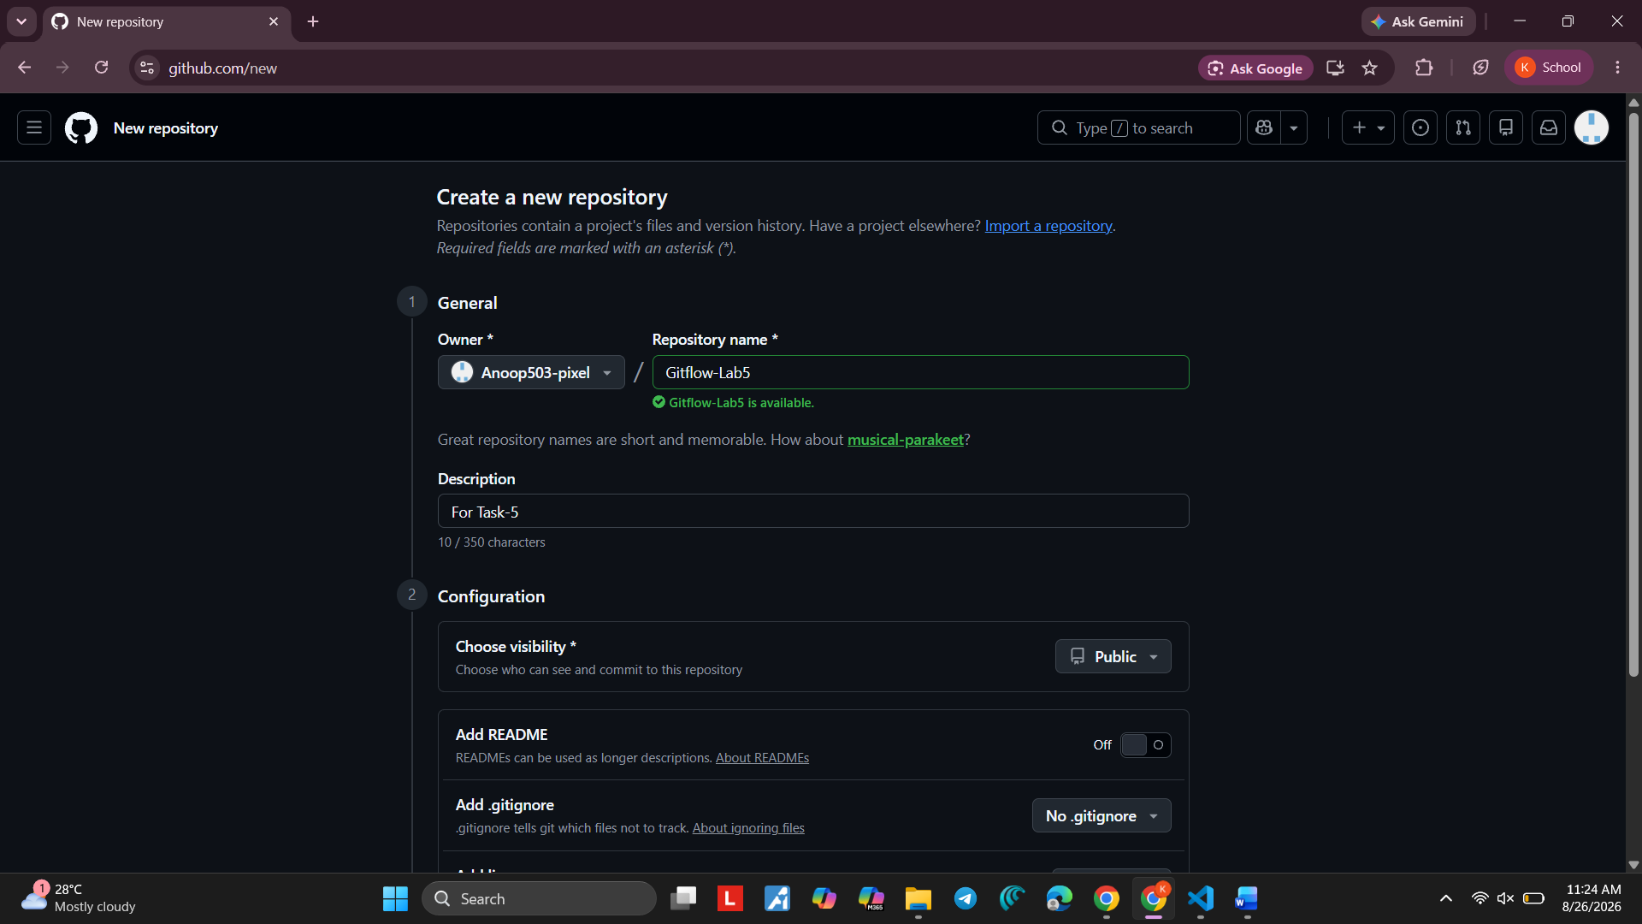
Screenshot 1 — Step 1

Step 2. Open the New Repository
What you see: After creating the repository, GitHub opens the Gitflow-Lab-5 repository page. The HTTPS repository address is visible.
Simple explanation: This page is the home page of the GitHub repository. We will connect the local project to this repository.

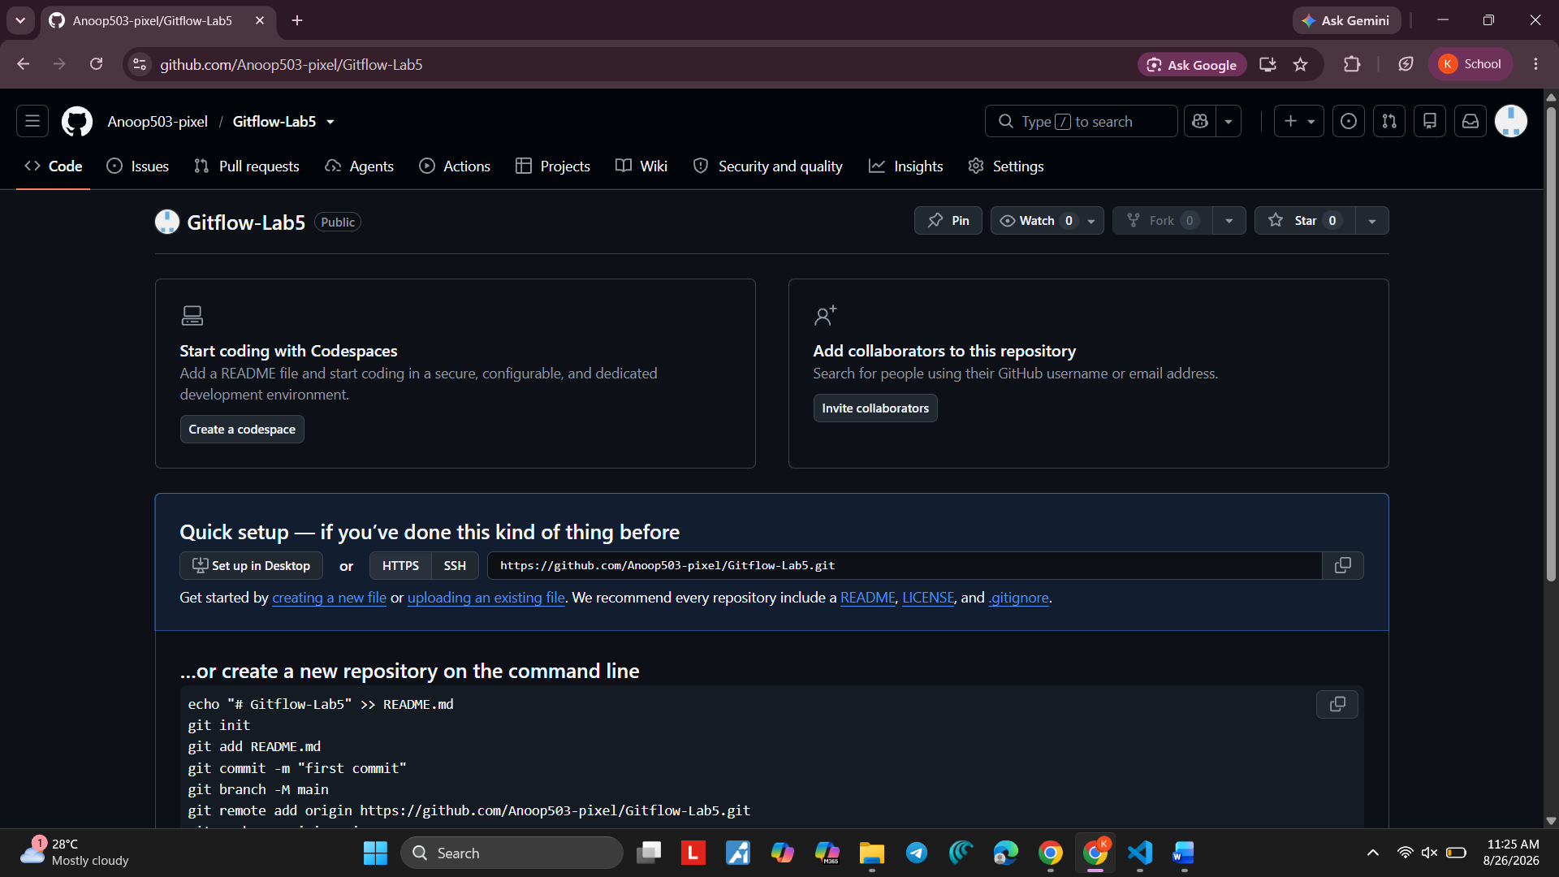
Screenshot 2 — Step 2

Step 3. Understand the Clone Command
What you see: The terminal shows a clone command and a "Repository not found" message for the example address.
Simple explanation: A clone command copies a GitHub repository to the computer. The important idea is that the URL must point to an existing repository.
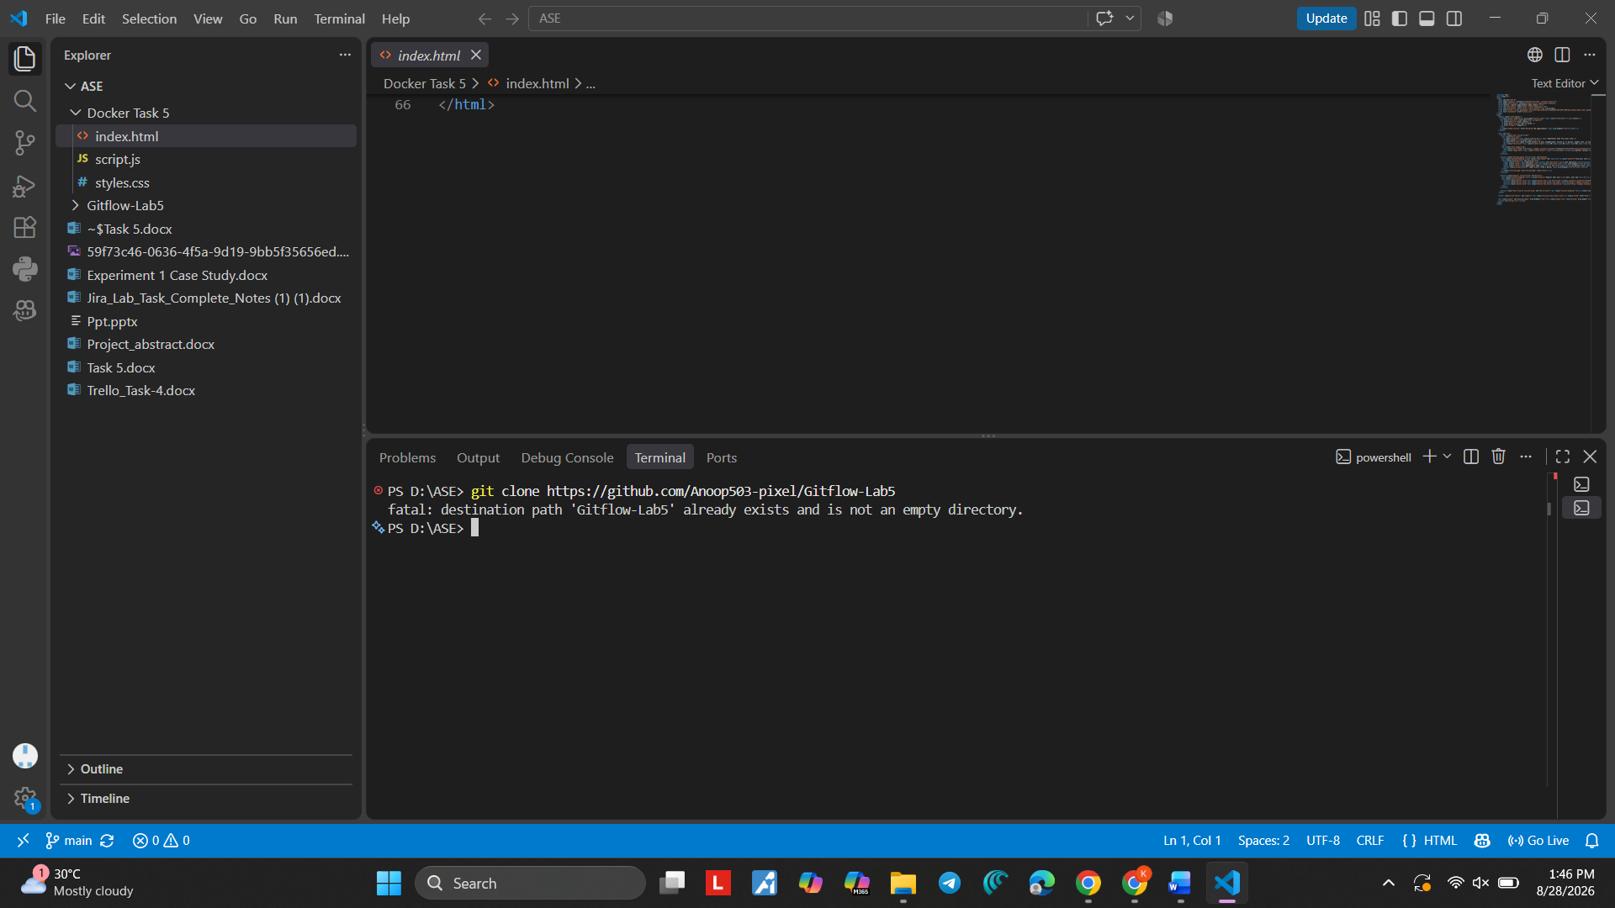
Screenshot 3 — Step 3

Step 4. Open the Project in VS Code
What you see: The VS Code Explorer shows the FSD workspace and the project folders.
Simple explanation: VS Code is used to work with the files and to run Git commands from the terminal.

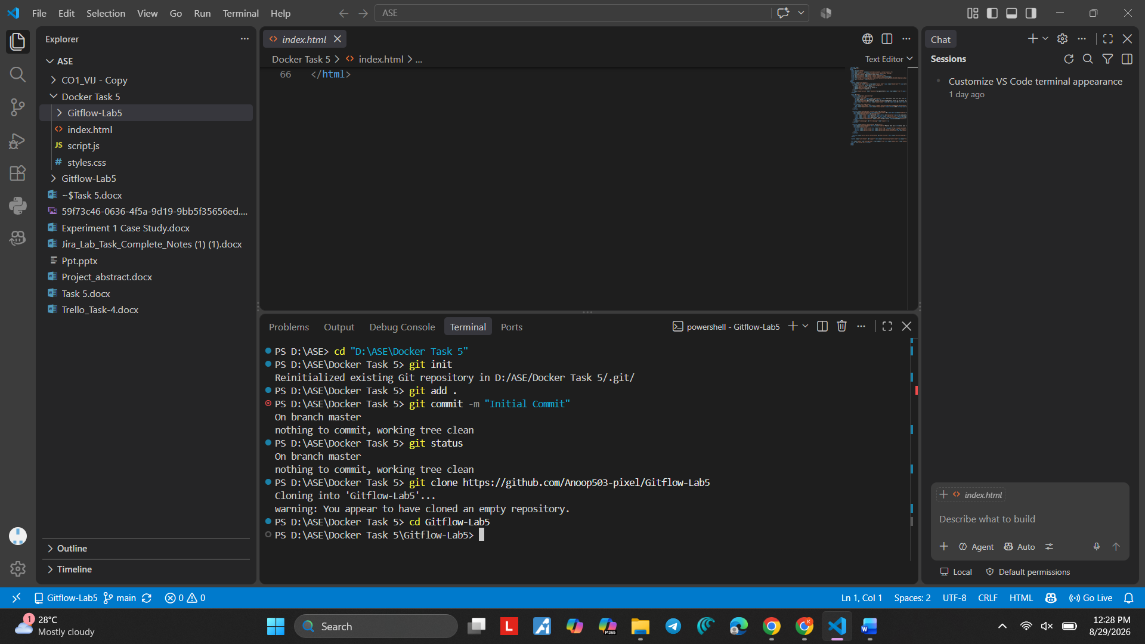
Screenshot 4 — Step 4

Step 5. Move to the Project Folder
What you see: The PowerShell terminal moves into D: FSD and then into the Gitflow-Lab-5 folder.
Simple explanation: Git commands should be run inside the project folder.

Command:
cd Gitflow-Lab-5
Purpose: Moves the terminal into the project folder.
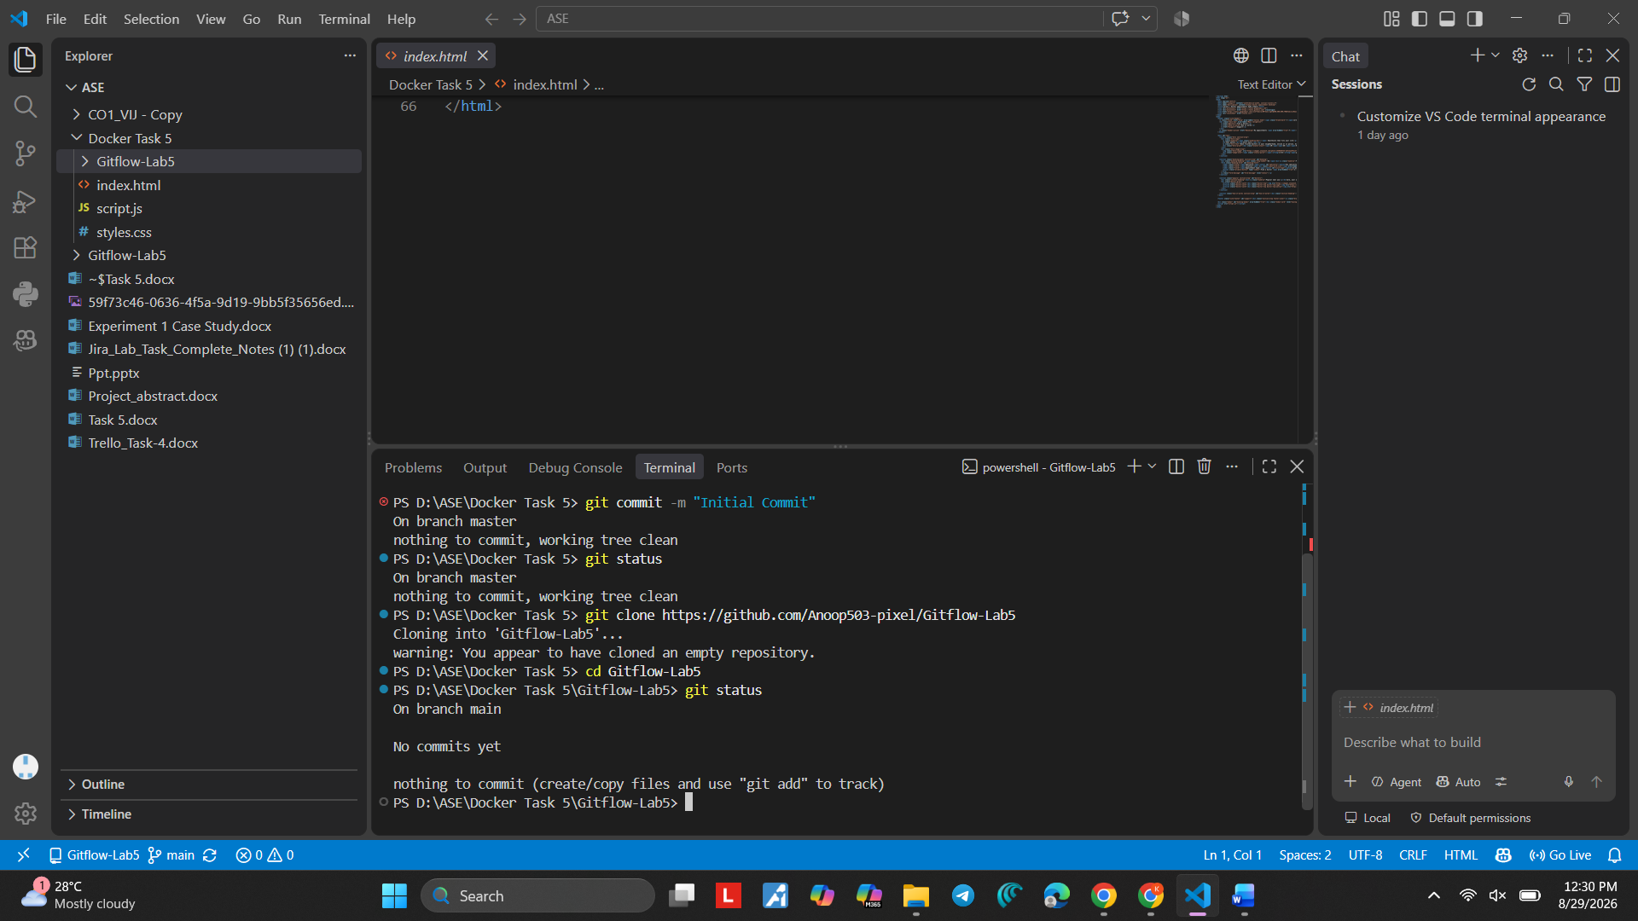
Screenshot 5 — Step 5

Step 6. Create README.md
What you see: README.md is created and git status shows it as an untracked file on the main branch.
Simple explanation: README.md is a simple file used to keep information about the project. Git is now detecting it as a new file.

Command:
git status
Purpose: Checks the current branch and file status.

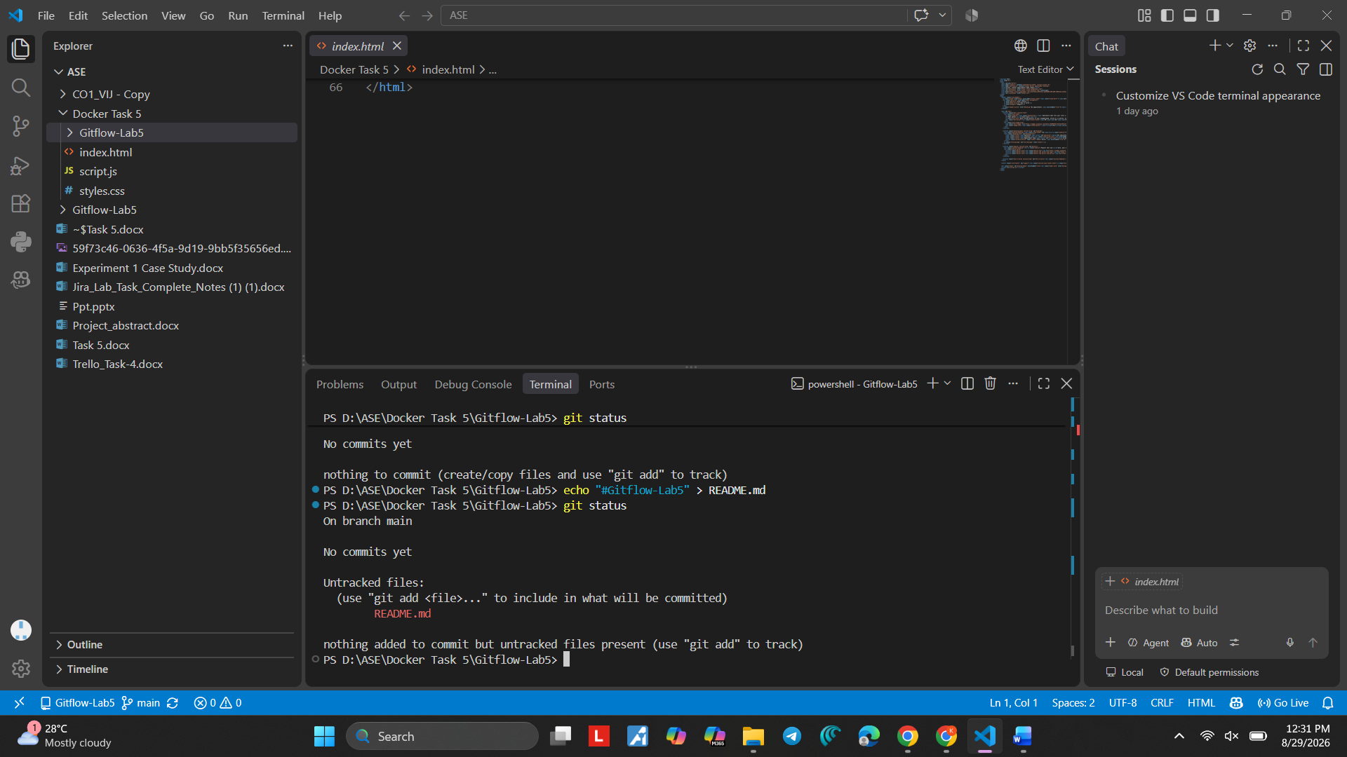
Screenshot 6 — Step 6

Step 7. Stage README.md
What you see: The command git add README.md is entered.
Simple explanation: git add puts the selected file into the staging area. Staging means the file is ready to be saved in a commit.

Command:
git add README.md
Purpose: Stages README.md for the next commit.
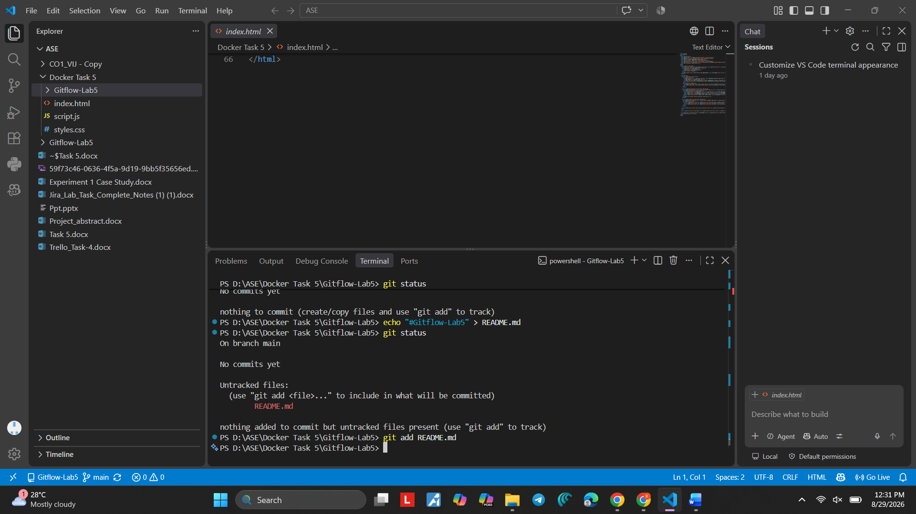
Screenshot 7 — Step 7

Step 8. Check the Staged File
What you see: git status shows README.md under "Changes to be committed". Simple explanation: This confirms that README.md has been staged successfully. Command:
git status

Purpose: Confirms that README.md is staged.

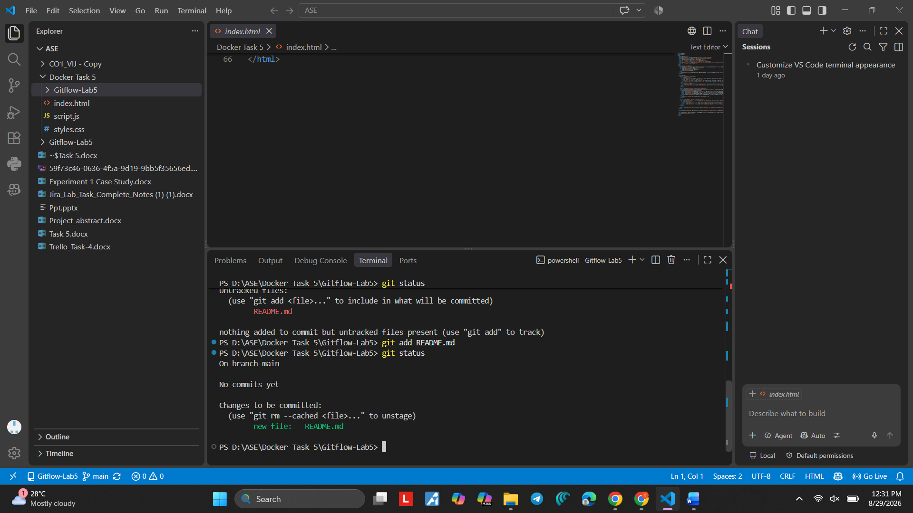
Screenshot 8 — Step 8

Step 9. Make the Initial Commit
What you see: The terminal shows the initial commit being created successfully.
Simple explanation: git commit saves the staged changes in Git history. The first saved version is the initial commit.

Command:
git commit -m "Initial commit"
Purpose: Saves the first project version.
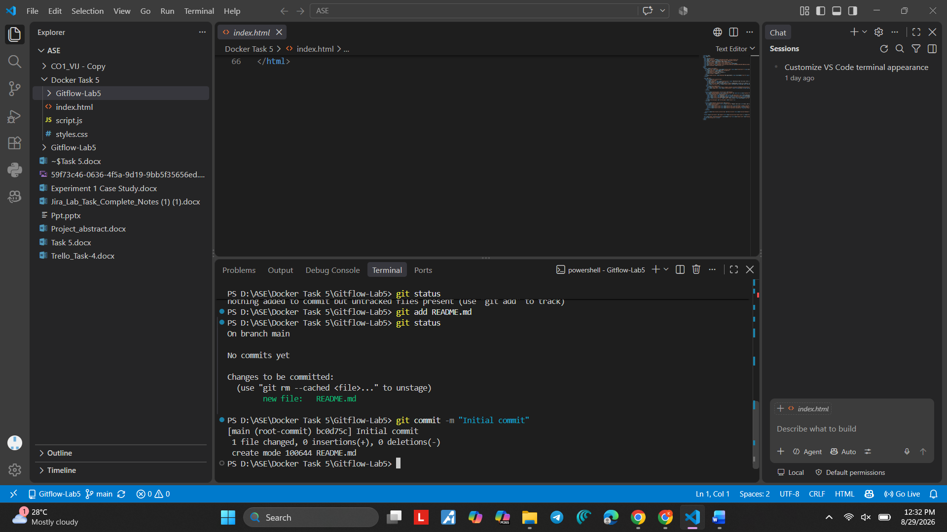
Screenshot 9 — Step 9

Step 10. Check the Remote Command
What you see: The terminal shows Git's usage/error message after an incorrect remote command.
Simple explanation: A Git command must be written in the correct format. If Git shows usage information, check the command before continuing.

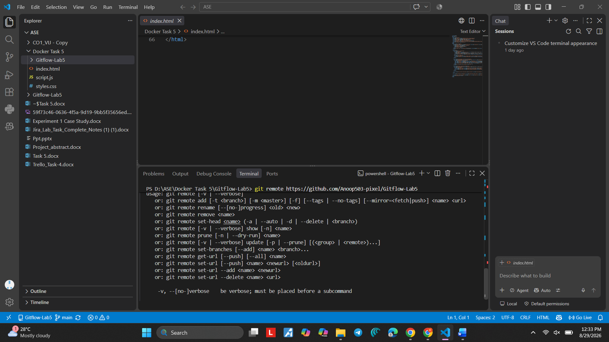
Screenshot 10 — Step 10

Step 11. Check the GitHub Remote
What you see: git remote -v shows the origin repository address.
Simple explanation: origin is the short name used for the GitHub repository connected to the local project.

Command:
git remote -v
Purpose: Shows the GitHub repository connected as origin.
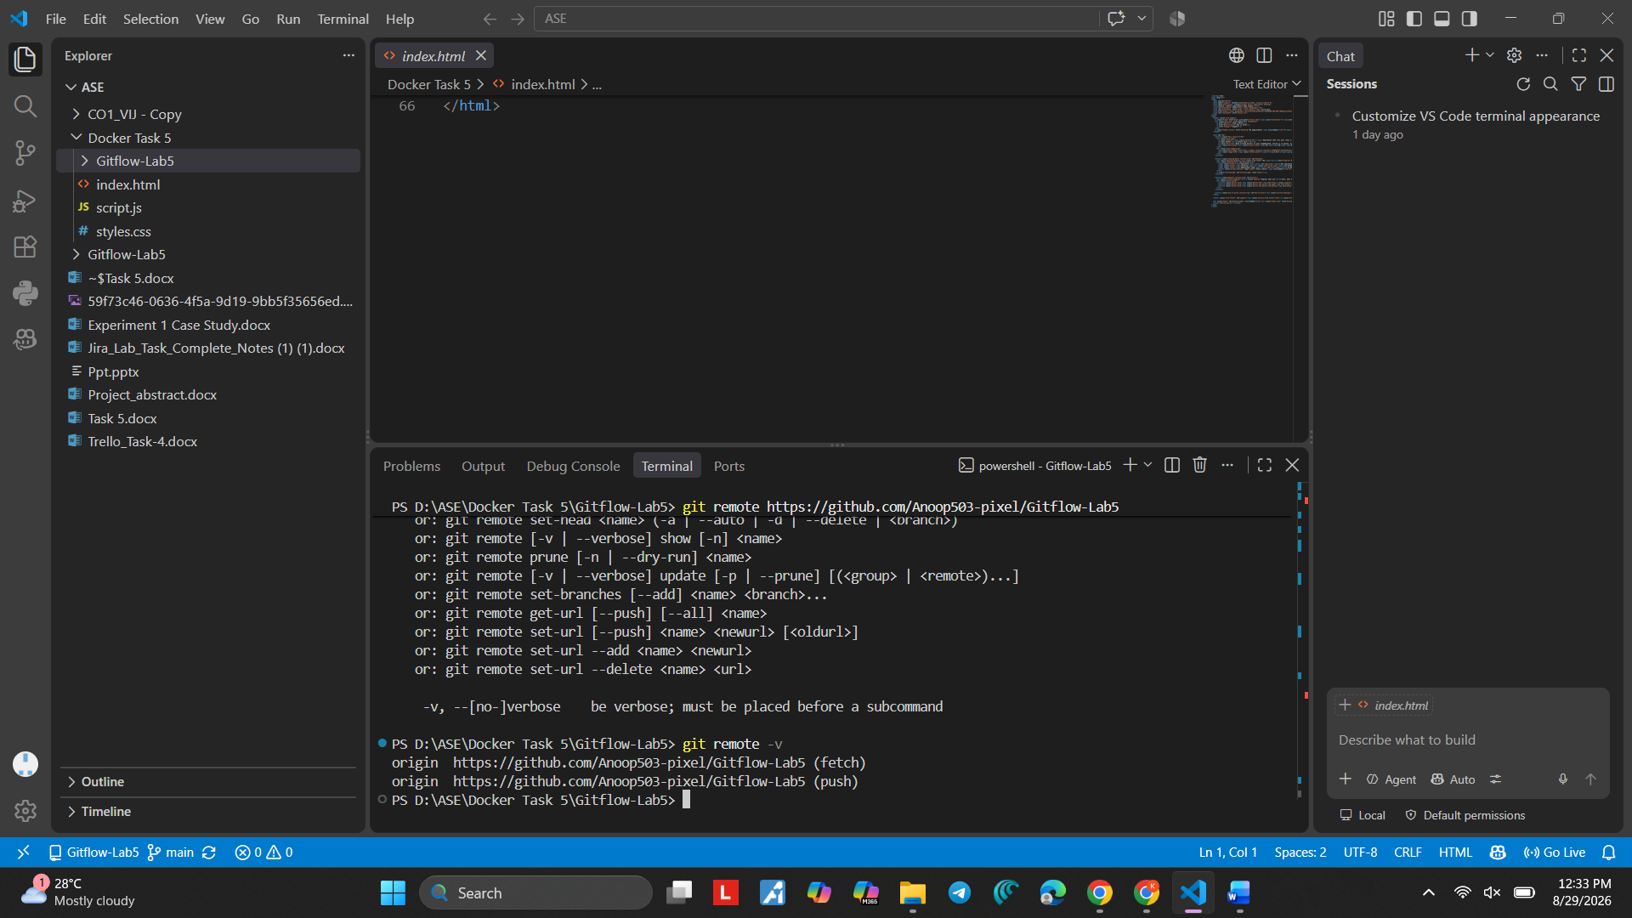
Screenshot 11 — Step 11

Step 12. Check the Commit History
What you see: The terminal shows git log --oneline with the Initial commit. Simple explanation: git log --oneline gives a short view of the saved commits. Command:
git log --oneline

Purpose: Shows a short list of commits.

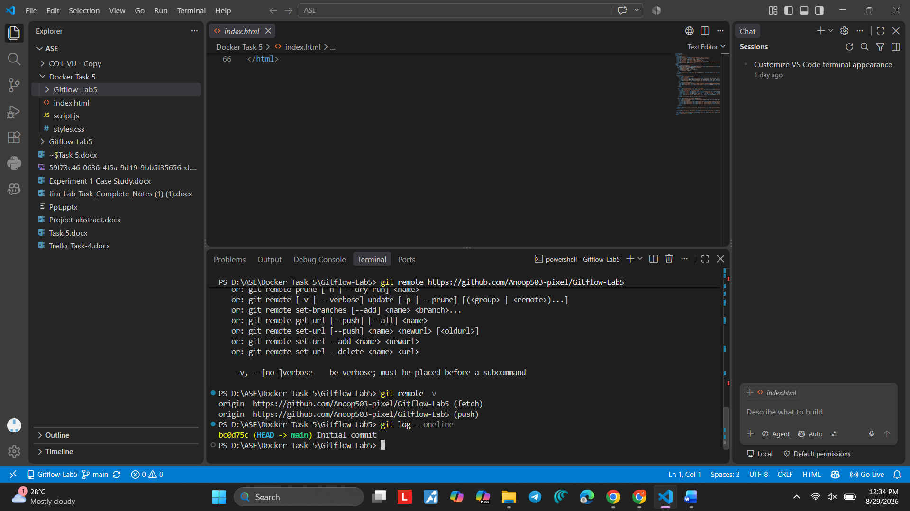
Screenshot 12 — Step 12

Step 13. Check the Repository on GitHub
What you see: GitHub shows the main branch, README.md, and the Initial commit.
Simple explanation: This confirms that the repository exists on GitHub and the initial project content is visible.
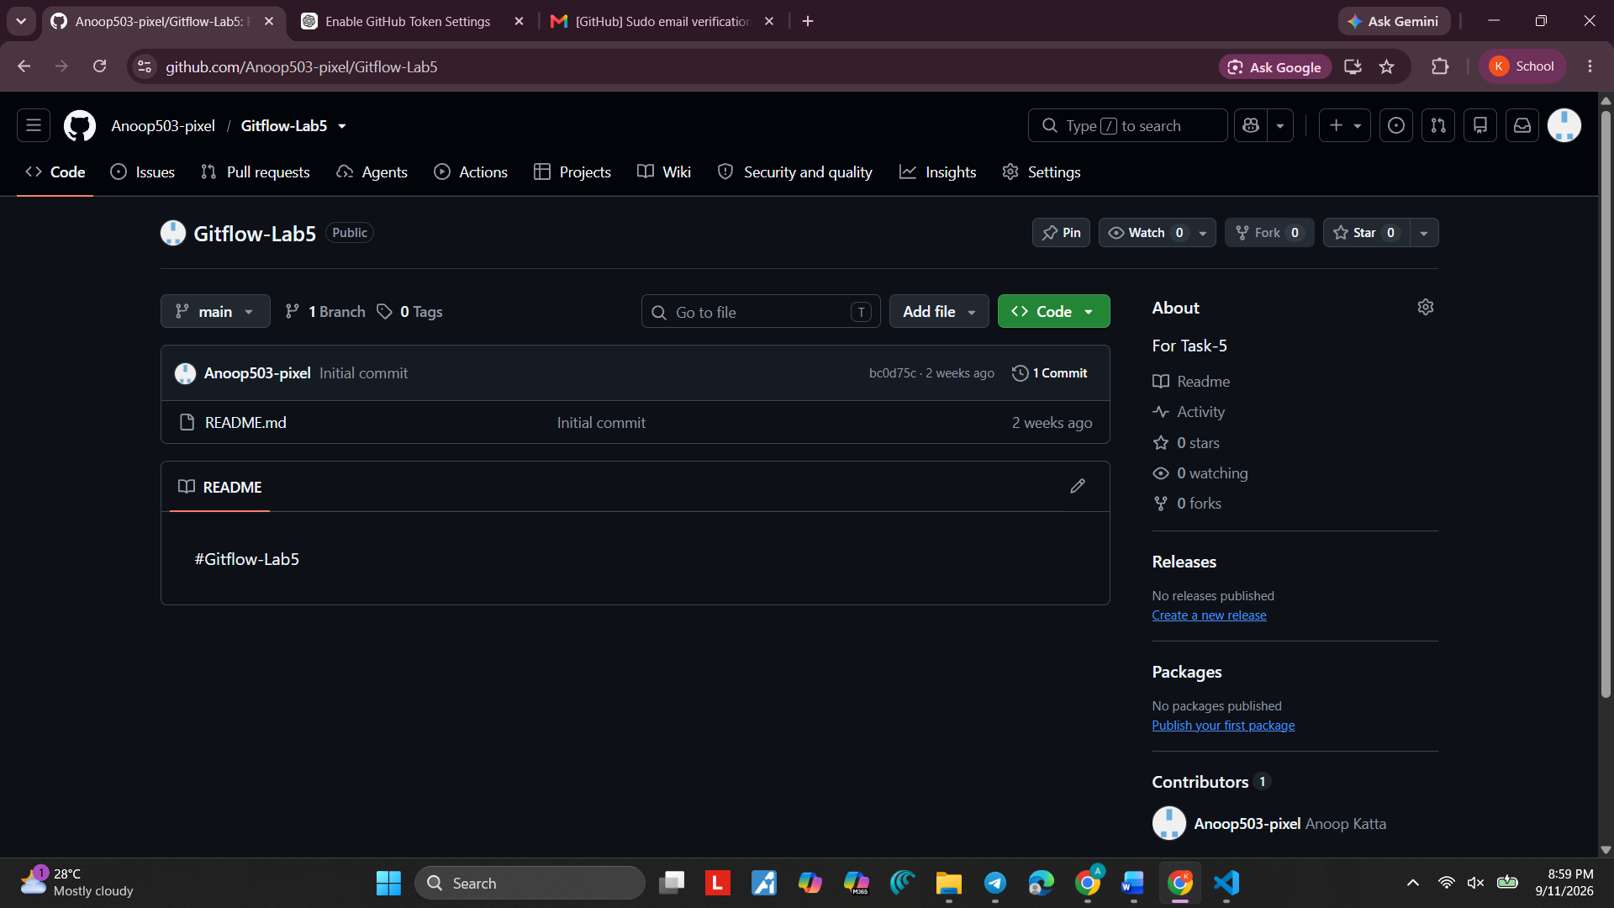
Screenshot 13 — Step 13

Step 14. Check Git Remote Carefully
What you see: The terminal again shows Git's remote command usage/error information.
Simple explanation: If the command is entered incorrectly, Git explains the correct usage. Follow the command format carefully.

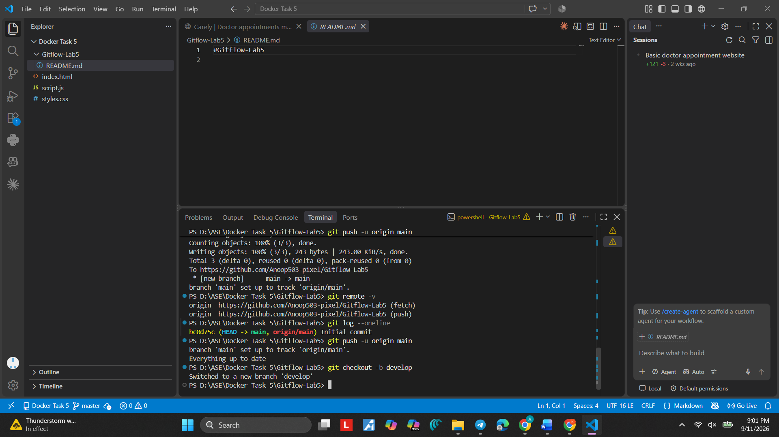
Screenshot 14 — Step 14

Step 15. Create the develop Branch
What you see: The command git checkout -b develop creates and switches to the develop branch. git branch lists develop and main.
Simple explanation: develop is the branch used for development work before changes are moved to main.

Command:
git checkout -b develop
Purpose: Creates and switches to develop.
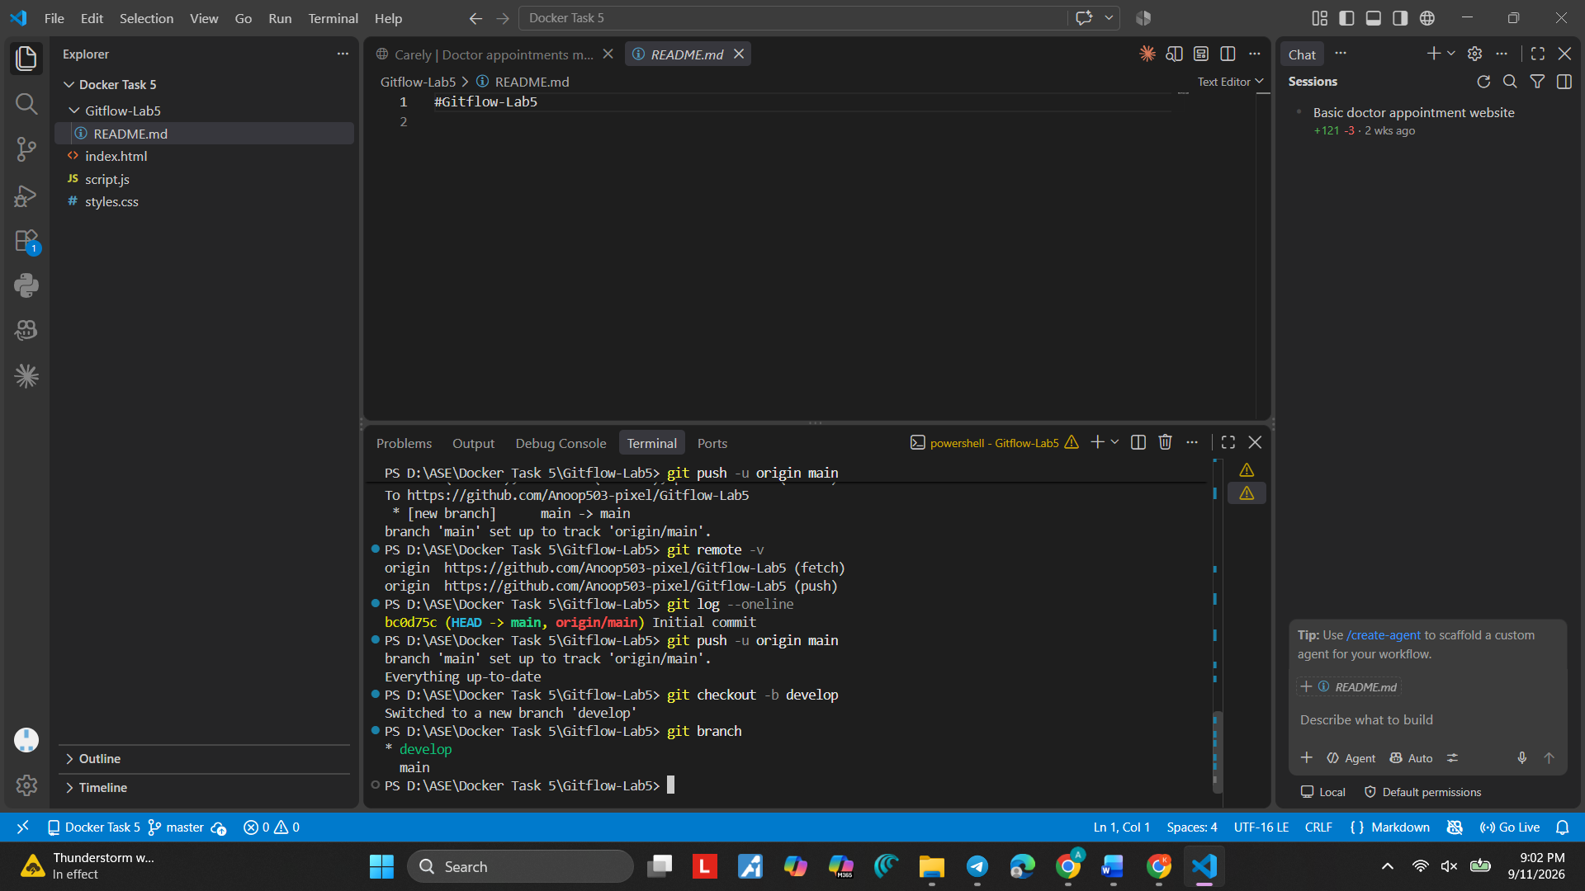
Screenshot 15 — Step 15

Step 16. Push develop to GitHub
What you see: The terminal shows git push -u origin develop completing successfully.
Simple explanation: The -u option connects the local develop branch with the remote develop branch on GitHub.

Command:
git push -u origin develop
Purpose: Uploads develop to GitHub and sets its upstream.

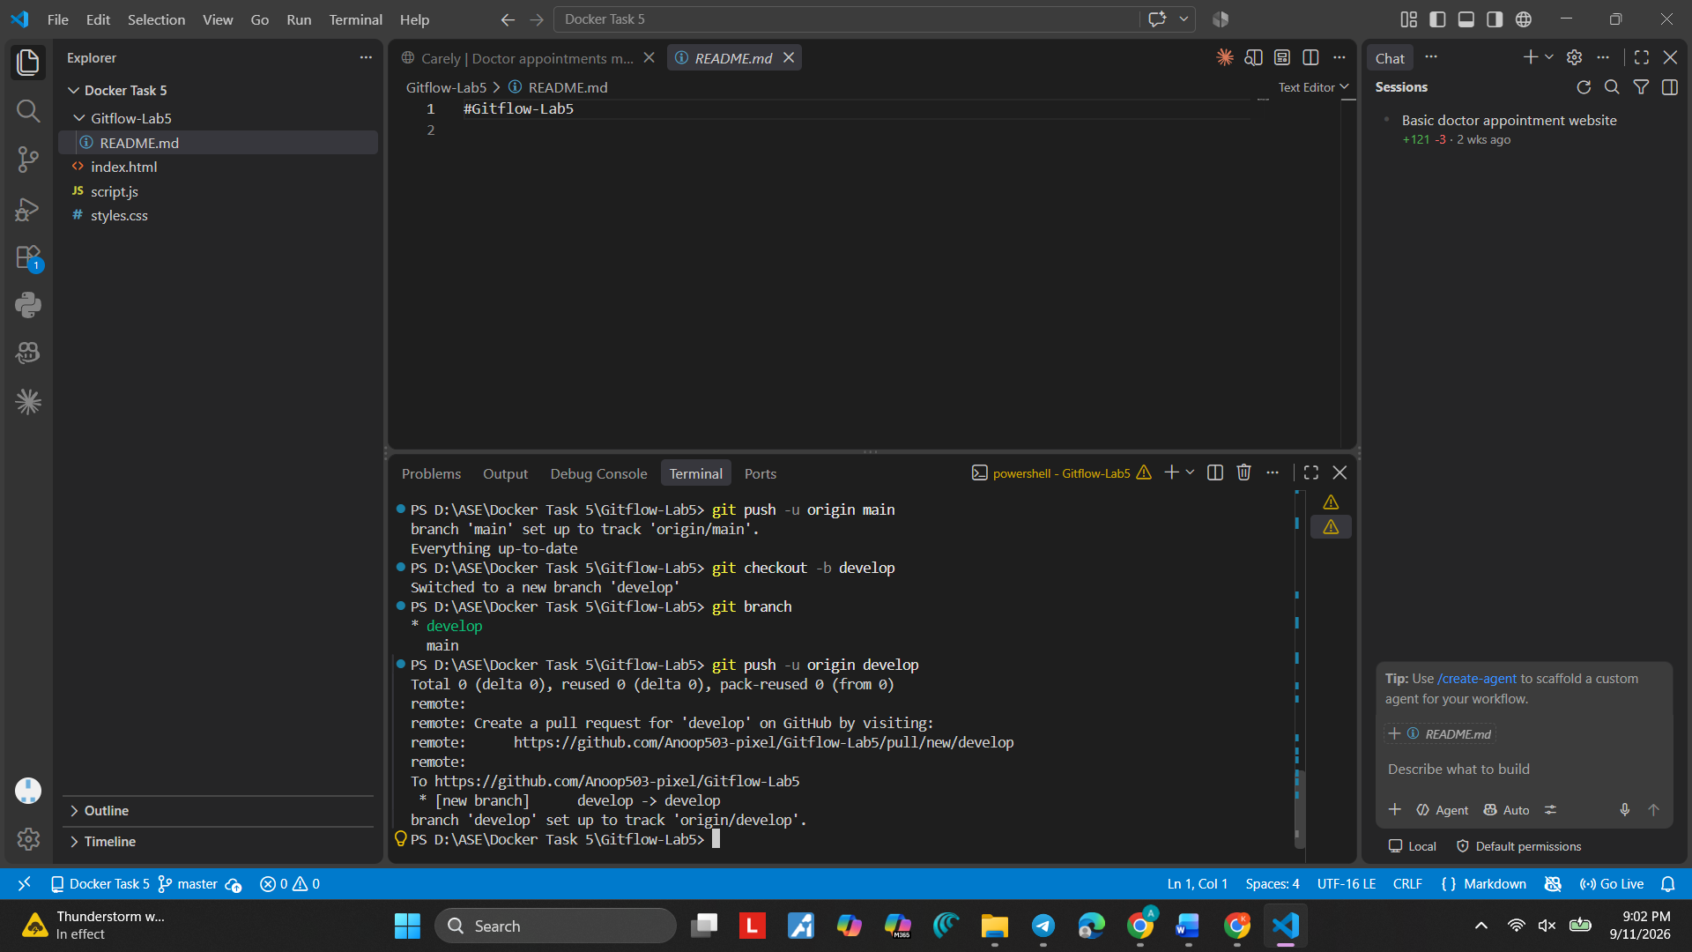
Screenshot 16 — Step 16

Step 17. Create feature/login
What you see: The terminal switches from develop to a new feature/login branch.
Simple explanation: A feature branch is used for one particular feature. Here the feature is login.

Command:
git checkout -b feature/login
Purpose: Creates and switches to feature/login.
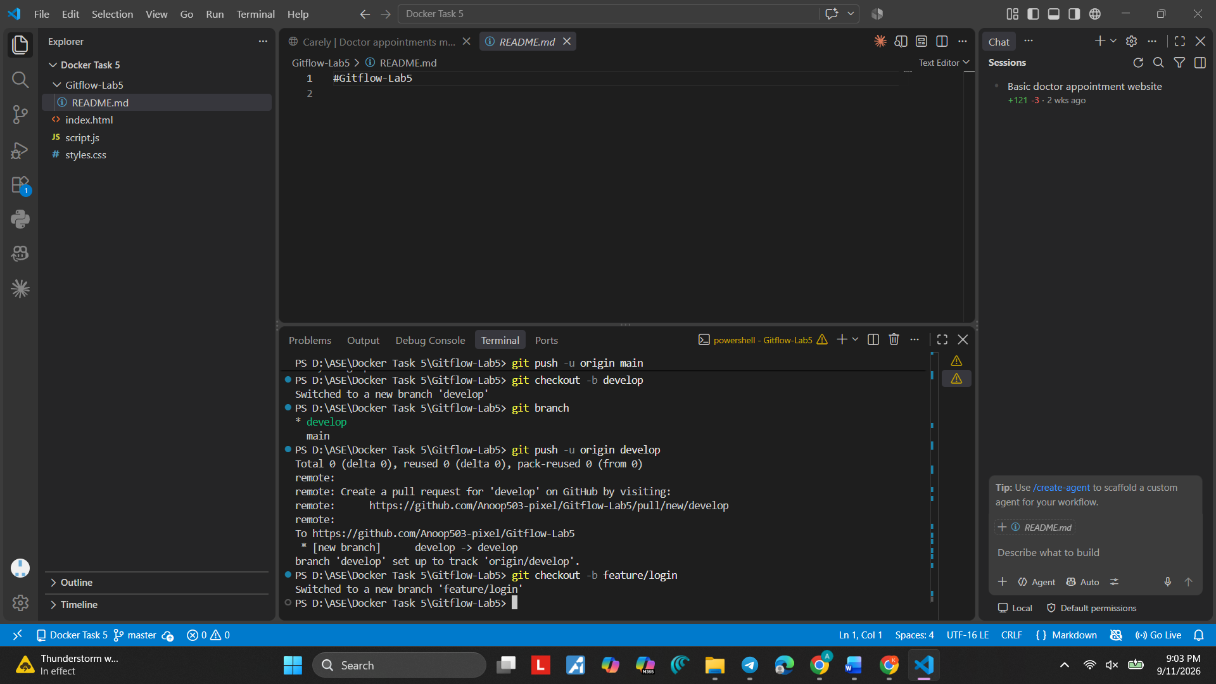
Screenshot 17 — Step 17

Step 18. Create app.py
What you see: The VS Code Explorer shows app.py as a new file in Gitflow-Lab-5.
Simple explanation: app.py will contain the small Python program used in this lab.
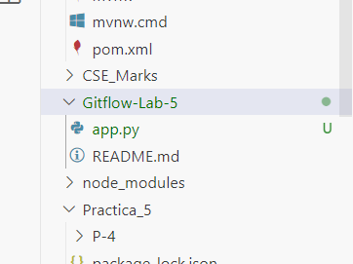
Screenshot 18 — Step 18

Step 19. Write the Login Program
What you see: The editor shows the login function and print(login("Student")) in app.py.
Simple explanation: The program receives a username and returns a welcome message.
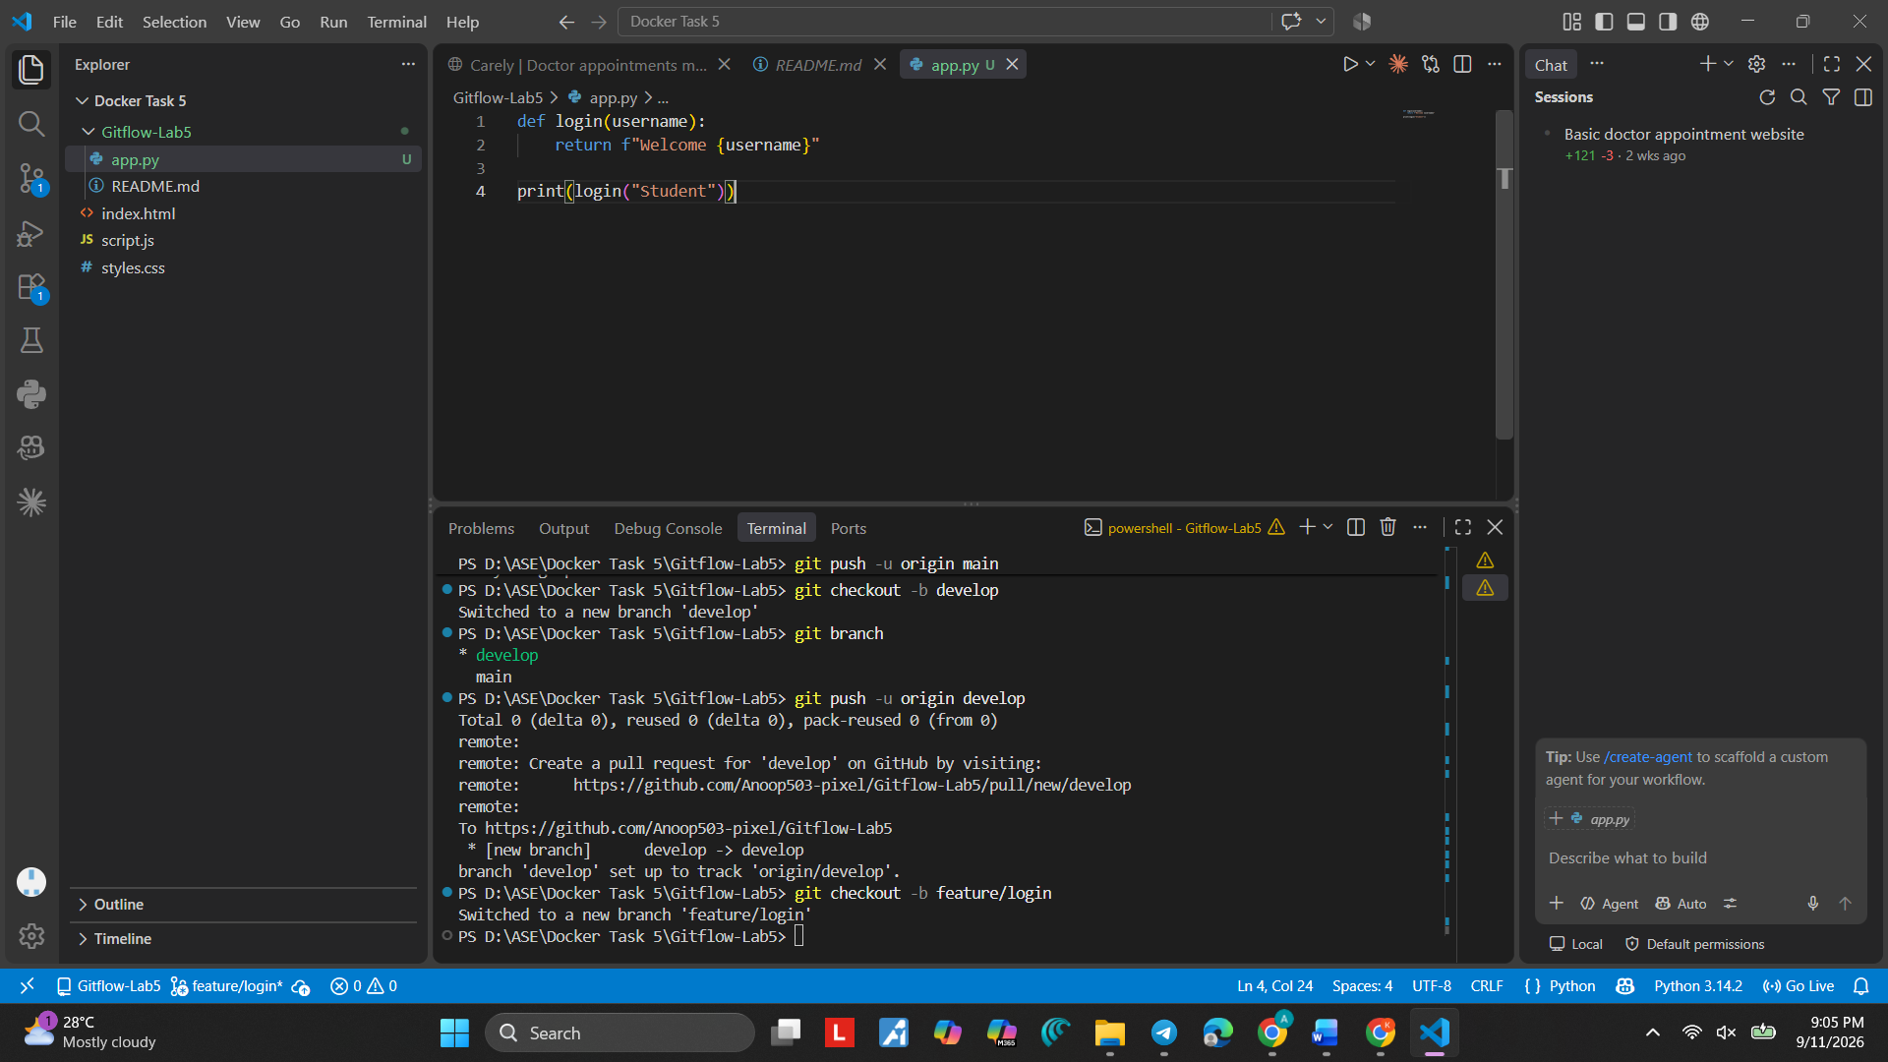

Screenshot 19 — Step 19

Step 20. Check the Python Command
What you see: The terminal shows an error after app.py was entered directly as a PowerShell command.
Simple explanation: A Python file should be run using Python, for example: python app.py.
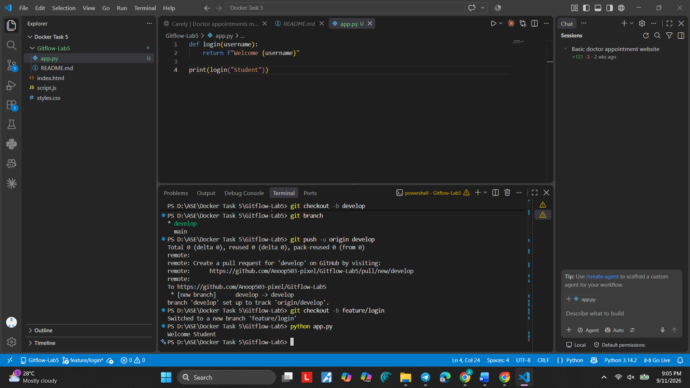
Screenshot 20 — Step 20

Step 21. Run app.py
What you see: The terminal shows python app.py producing "Welcome Student", followed by git status showing app.py as untracked.
Simple explanation: The program is working. Git also knows that app.py is a new file that has not yet been staged.

Command:
python app.py
Purpose: Runs the Python program.
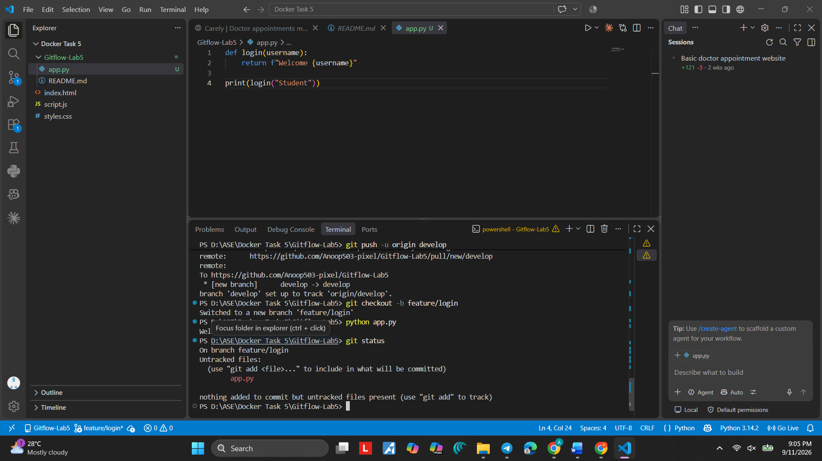
Screenshot 21 — Step 21

Step 22. Check the New File Again
What you see: The terminal again shows python app.py producing "Welcome Student" and git status showing app.py as untracked.
Simple explanation: This confirms both the program output and the Git status.
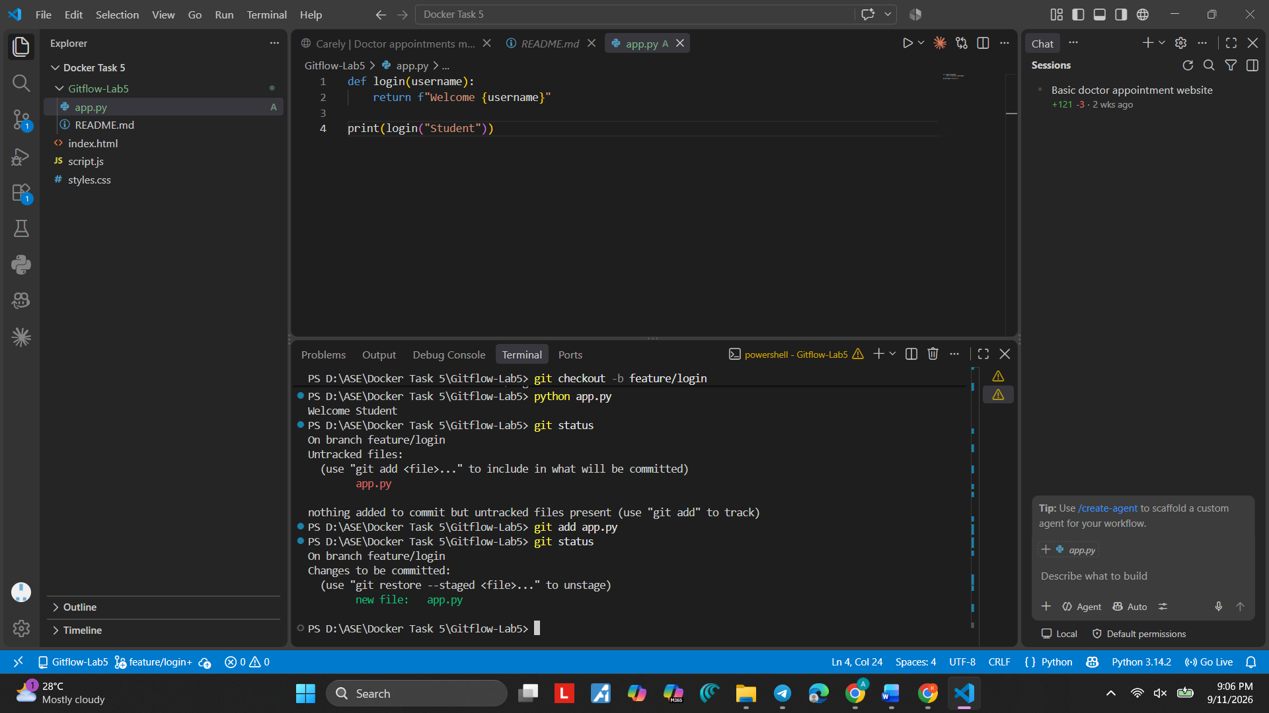
Screenshot 22 — Step 22

Step 23. Commit the Login Feature
What you see: The command git commit -m "Add login feature" creates the feature/login commit.
Simple explanation: The commit message tells us what was added. This saves the login feature in Git history.

Command:
git commit -m "Add login feature"
Purpose: Saves the login feature in Git history.
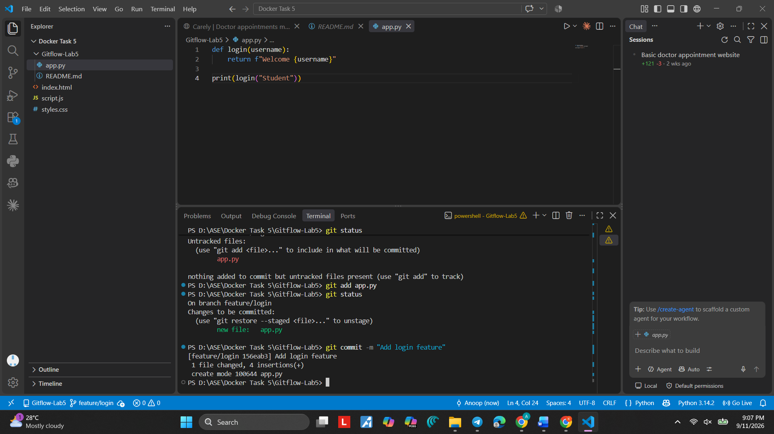
Screenshot 23 — Step 23

Step 24. Stage app.py
What you see: The terminal shows git add app.py and git status with app.py staged.
Simple explanation: The file is now ready to be included in the next commit.

Command:
git add app.py
Purpose: Stages app.py.
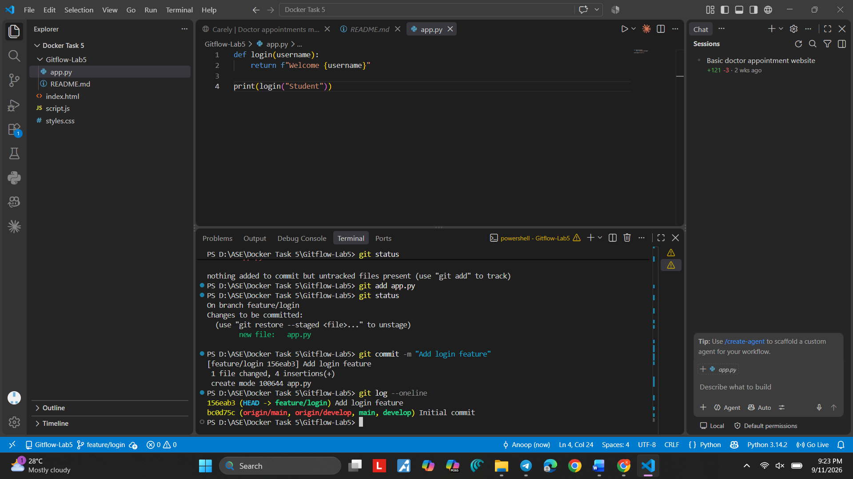
Screenshot 24 — Step 24

Step 25. Check and Push feature/login
What you see: The terminal shows the Add login feature commit, the short log, and the feature/login push.
Simple explanation: This step checks the feature history and sends the feature branch to GitHub.

Command:
git push -u origin feature/login
Purpose: Uploads feature/login to GitHub.
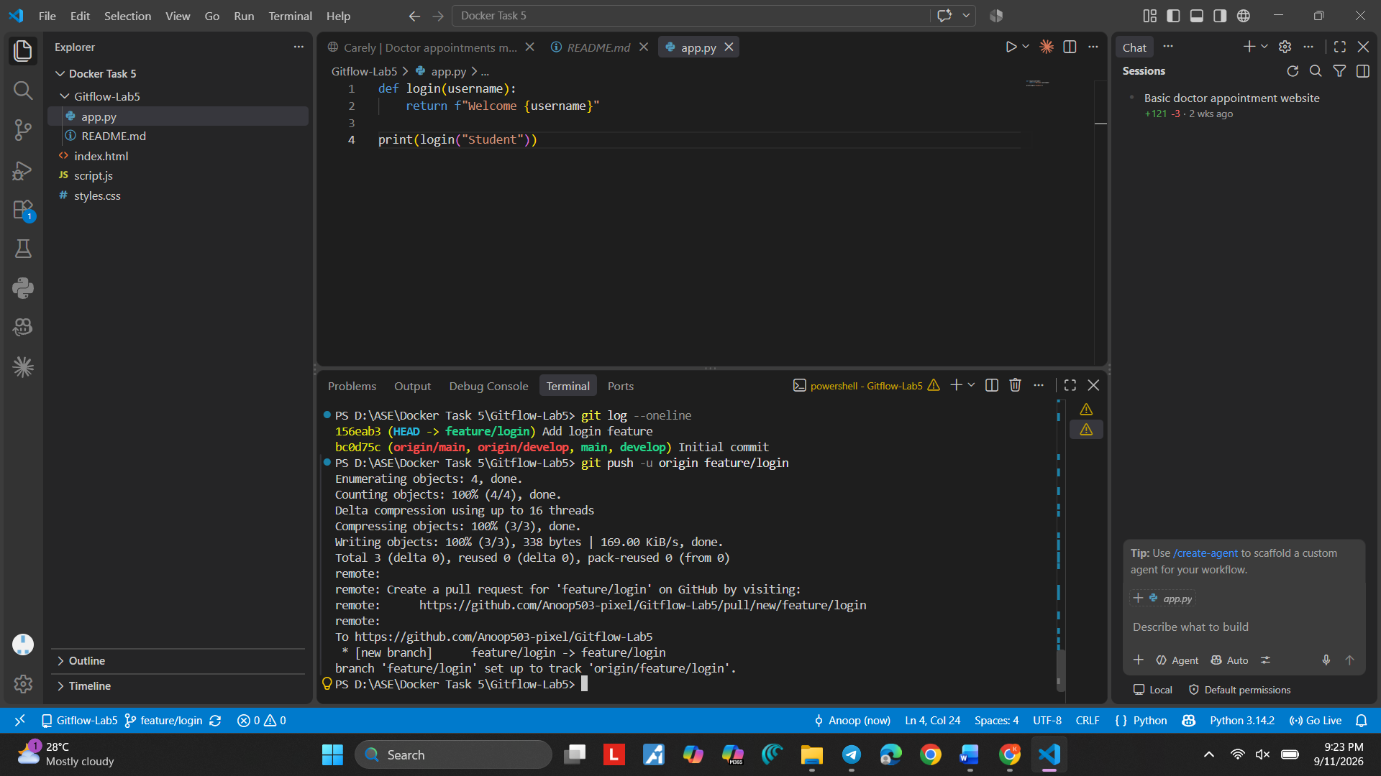
Screenshot 25 — Step 25

Step 26. See feature/login on GitHub
What you see: The GitHub repository page shows a recent push for feature/login.
Simple explanation: This confirms that the feature branch has been uploaded to GitHub.
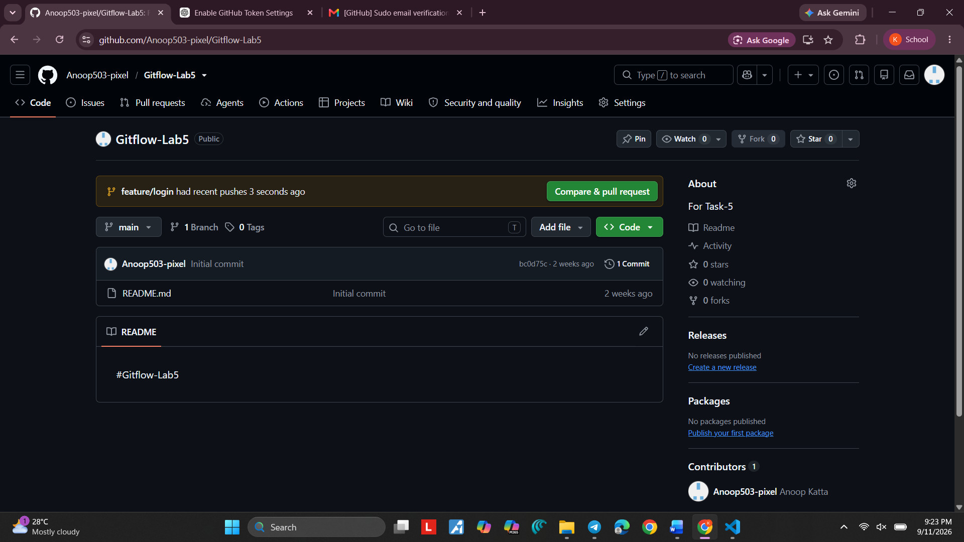
Screenshot 26 — Step 26

Step 27. Open feature/login Branch
What you see: GitHub shows feature/login with app.py and README.md and indicates that the branch is ahead of main.
Simple explanation: The feature branch contains the login work separately from main.
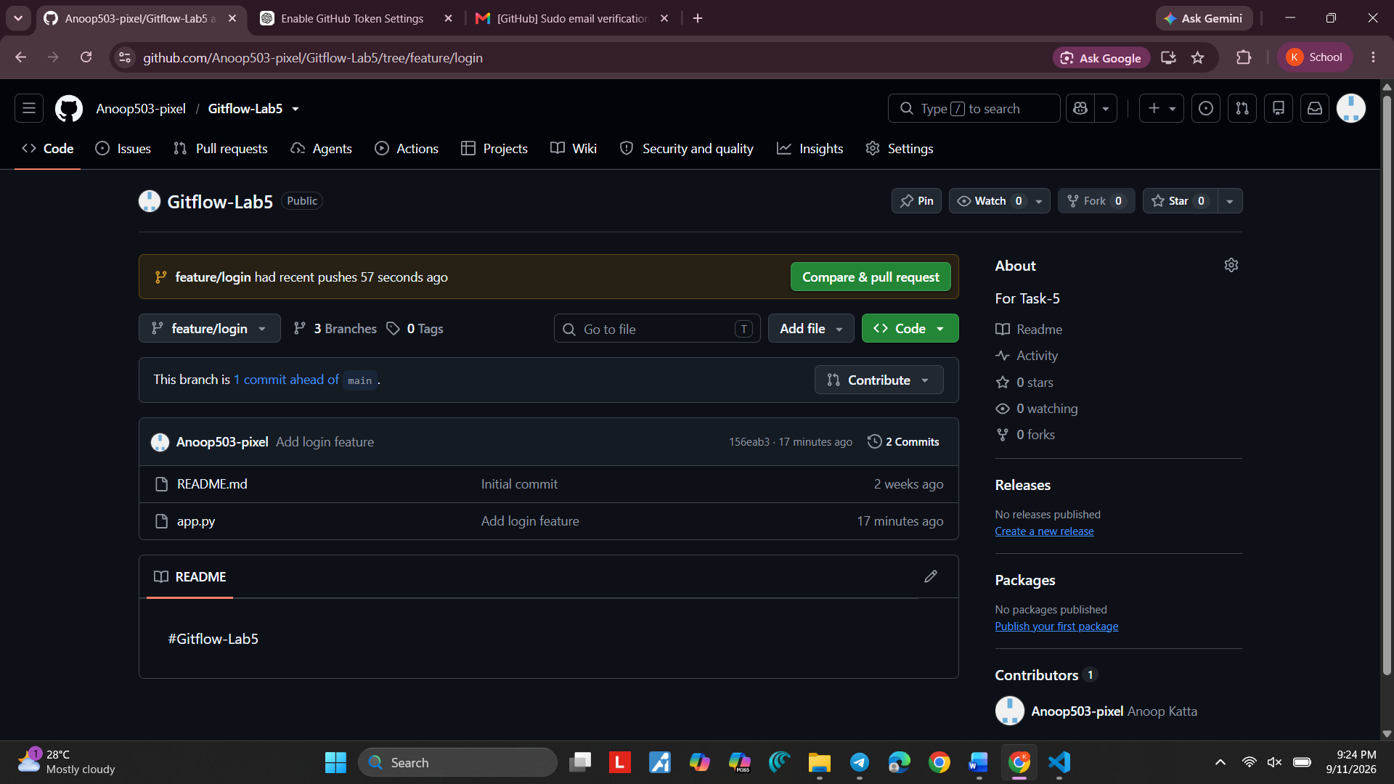
Screenshot 27 — Step 27

Step 28. Review feature/login History
What you see: The terminal shows the staged app.py, the Add login feature commit, and the Git history.
Simple explanation: This is a quick check that the feature work was saved correctly.

Command:
git log --oneline
Purpose: Shows the short commit history.
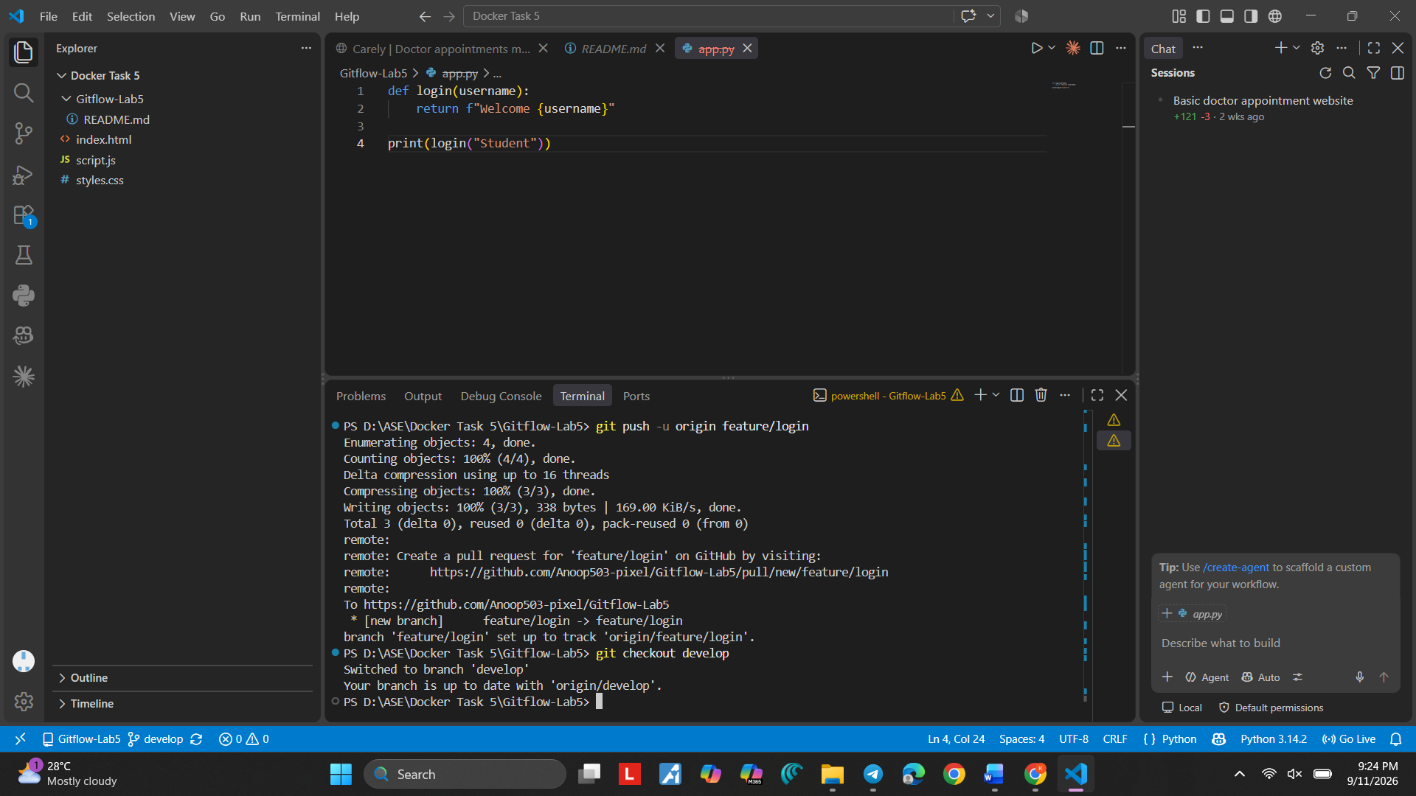
Screenshot 28 — Step 28

Step 29. Finish the feature/login Push
What you see: The terminal shows the push progress and successful upload to GitHub.
Simple explanation: The remote feature/login branch is now updated.

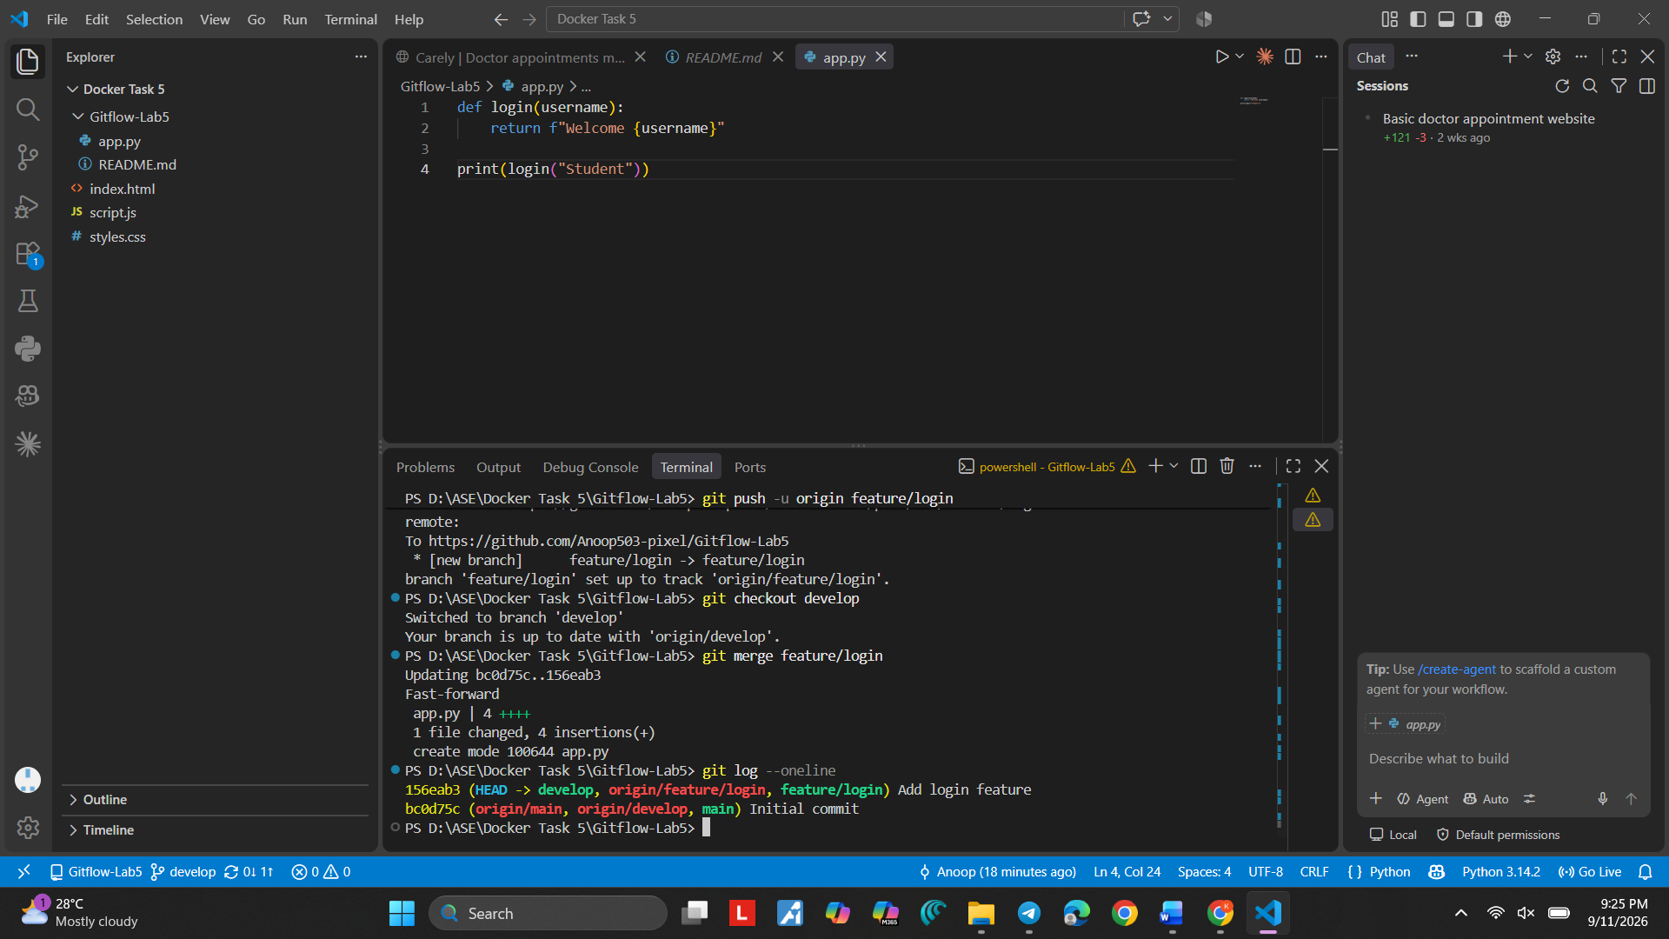
Screenshot 29 — Step 29

Step 30. Merge feature/login into develop
What you see: The terminal shows git merge feature/login on develop and the message Fast-forward.
Simple explanation: The login feature is now included in develop. Fast-forward means Git could move develop forward without creating a separate merge commit.

Command:
git merge feature/login
Purpose: Combines feature/login into the current develop branch.
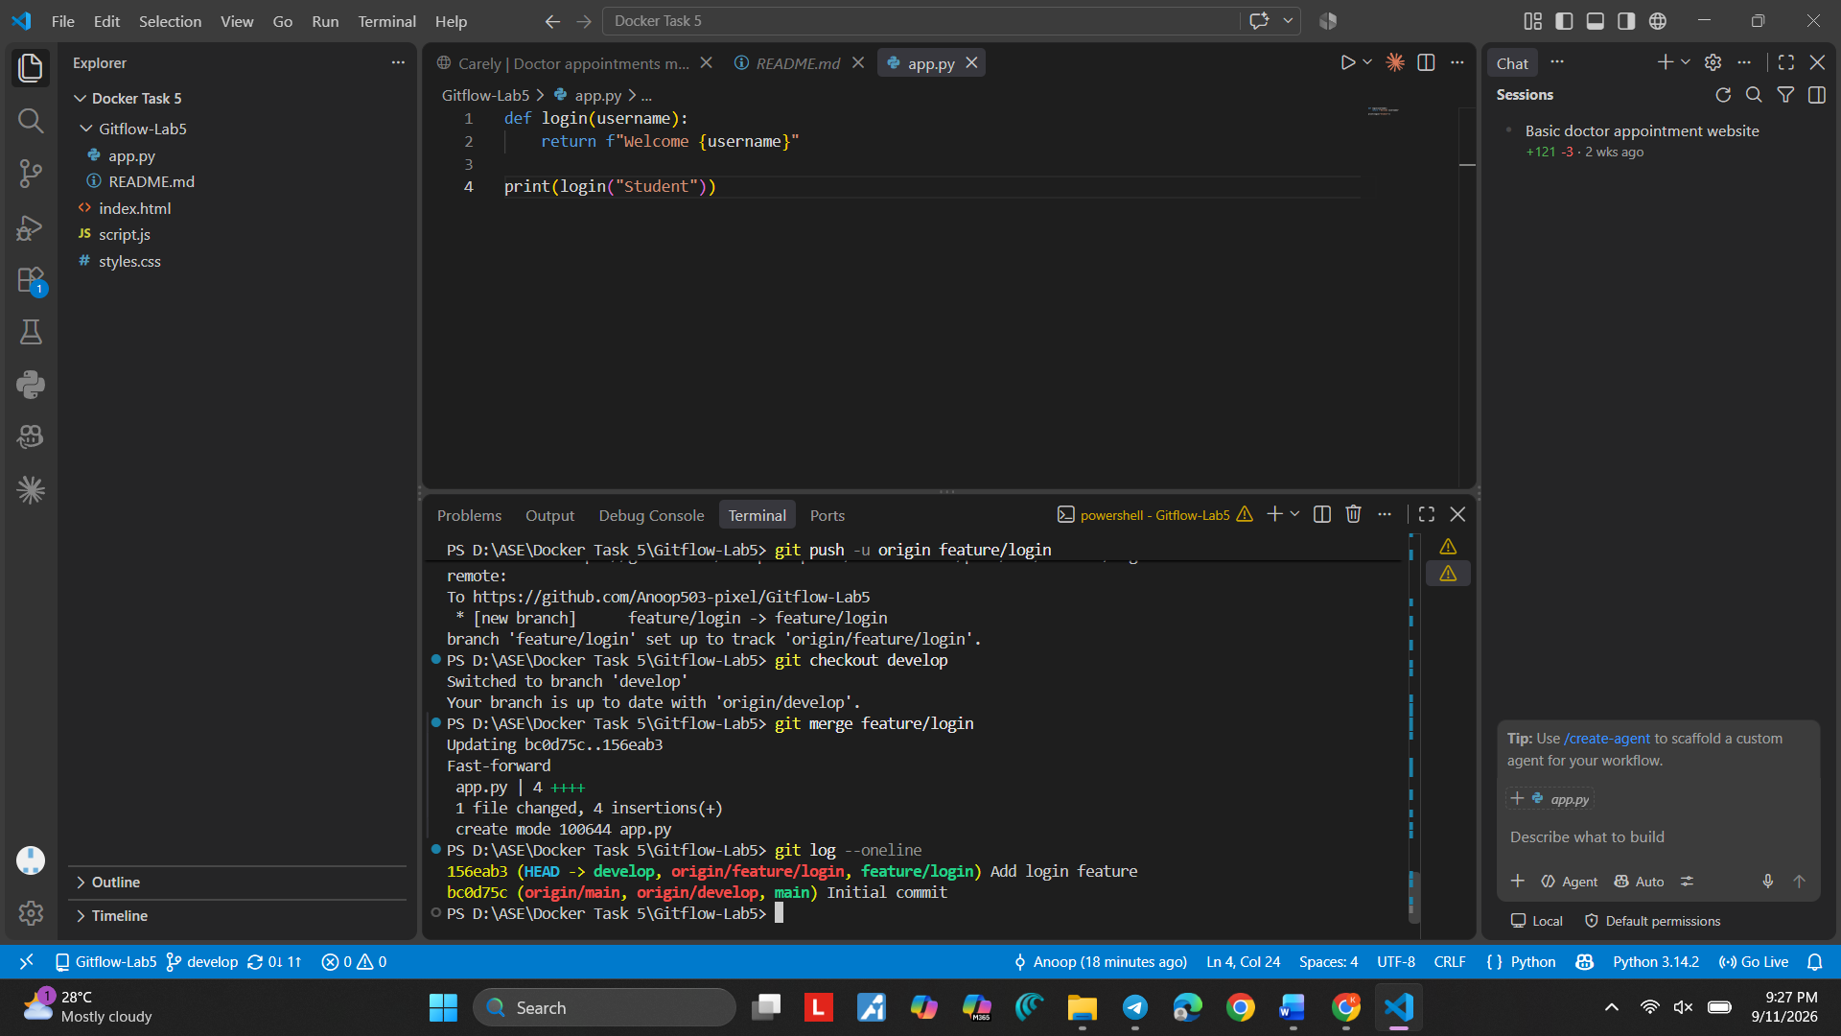
Screenshot 30 — Step 30

Step 31. Push Updated develop
What you see: The terminal shows git log --oneline and git push origin develop completing successfully.

Simple explanation: The updated develop branch is now available on GitHub.

Command:
git push origin develop
Purpose: Uploads the updated develop branch.
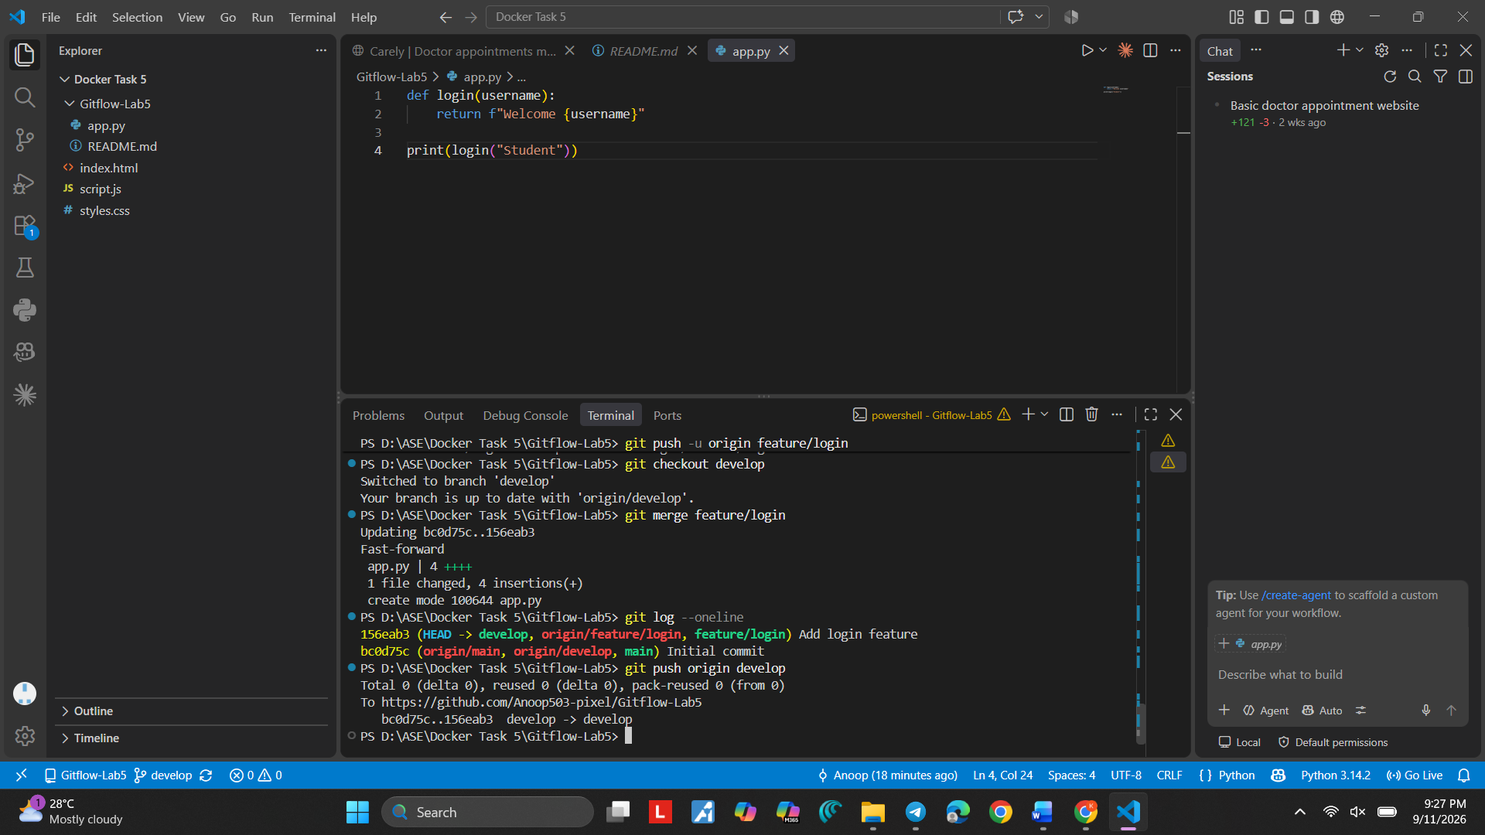
Screenshot 31 — Step 31

Step 32. Check GitHub Branches
What you see: GitHub shows main, develop, and feature/login in the branch list.
Simple explanation: This is the Gitflow branch structure created so far.
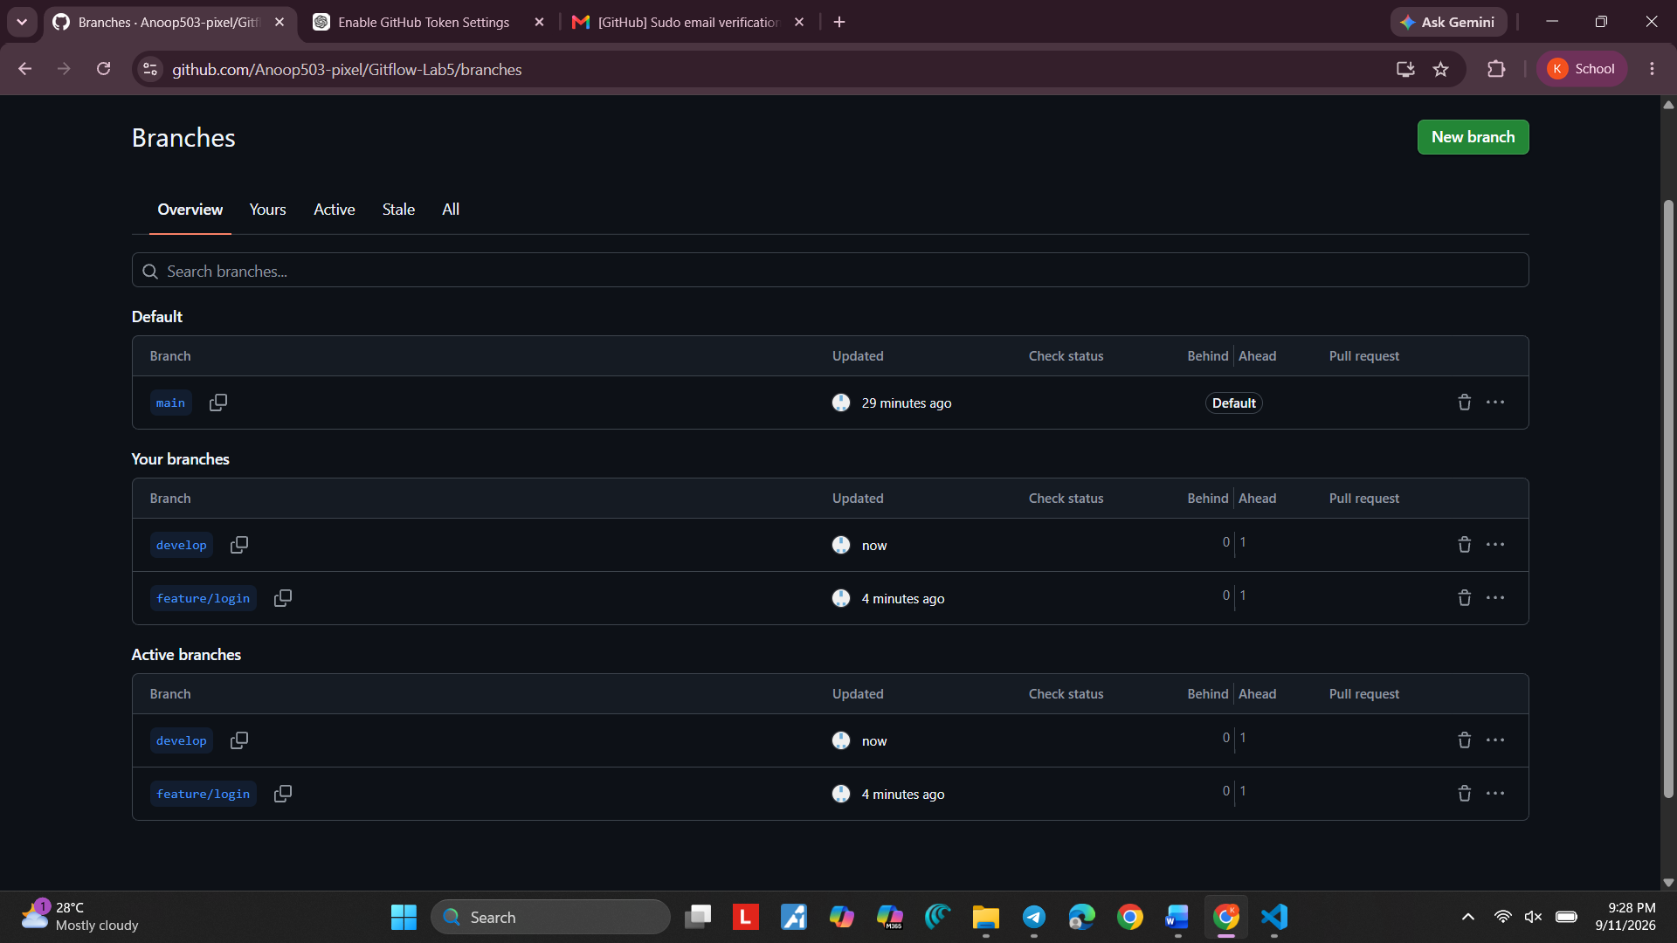
Screenshot 32 — Step 32

Step 33. Prepare the Conflict Branch
What you see: The terminal shows branch history, a develop push, the branch list, and creation of feature/conflict.
Simple explanation: feature/conflict will be used to demonstrate a merge conflict.

Command:
git checkout -b feature/conflict
Purpose: Creates and switches to feature/conflict.
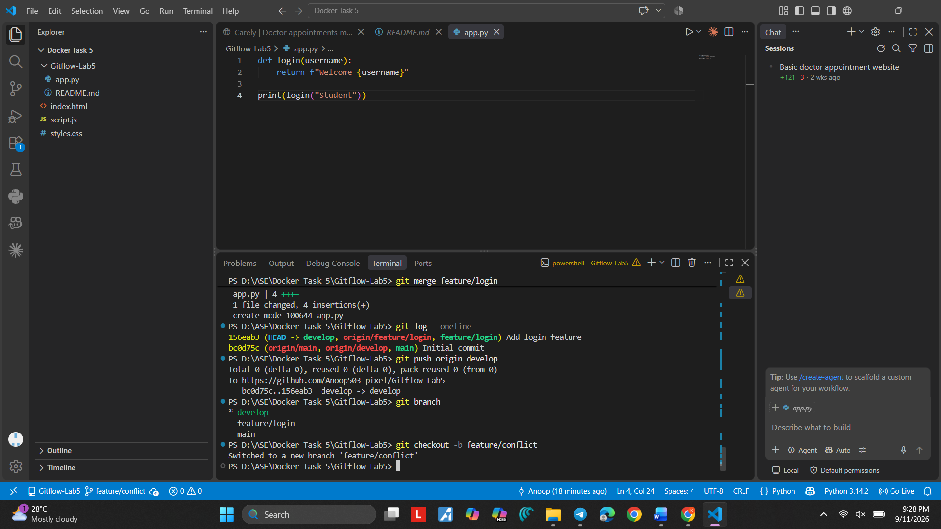
Screenshot 33 — Step 33

Step 34. Open README.md
What you see: VS Code shows README.md with the Gitflow Lab 5 heading while working on the conflict branch.
Simple explanation: README.md will be changed on different branches so Git has two different versions to compare.
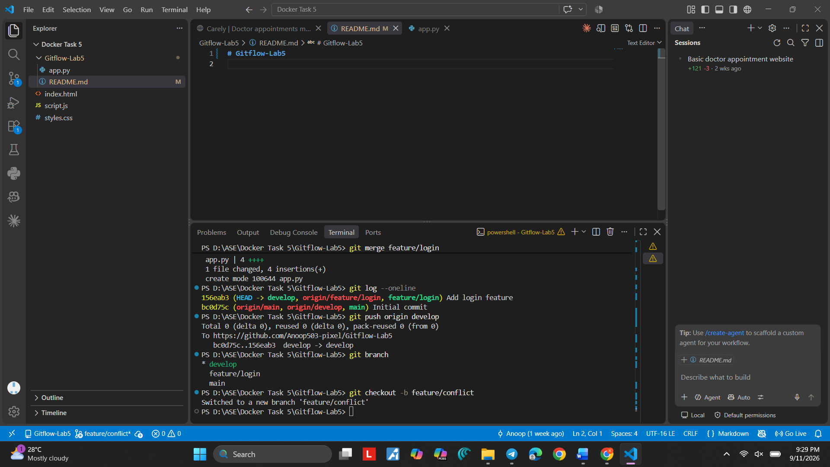

Step 35. Change the Feature Version
What you see: README.md shows "Gitflow Lab 5 - Feature Version".
Simple explanation: This creates the feature-side version of the README file.
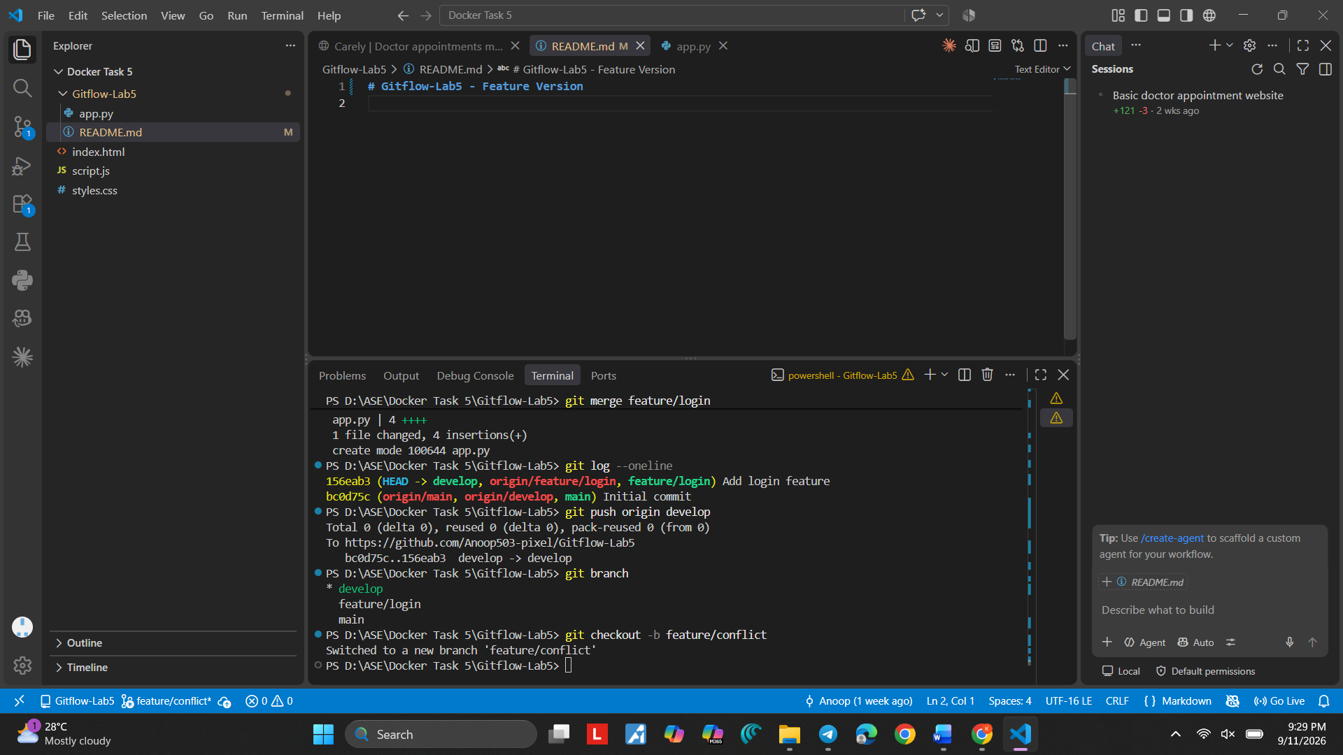
Screenshot 35 — Step 35

Step 36. Switch to feature/conflict
What you see: The terminal shows git checkout -b feature/conflict and confirms the branch switch.
Simple explanation: The conflict work is being done on this feature branch.
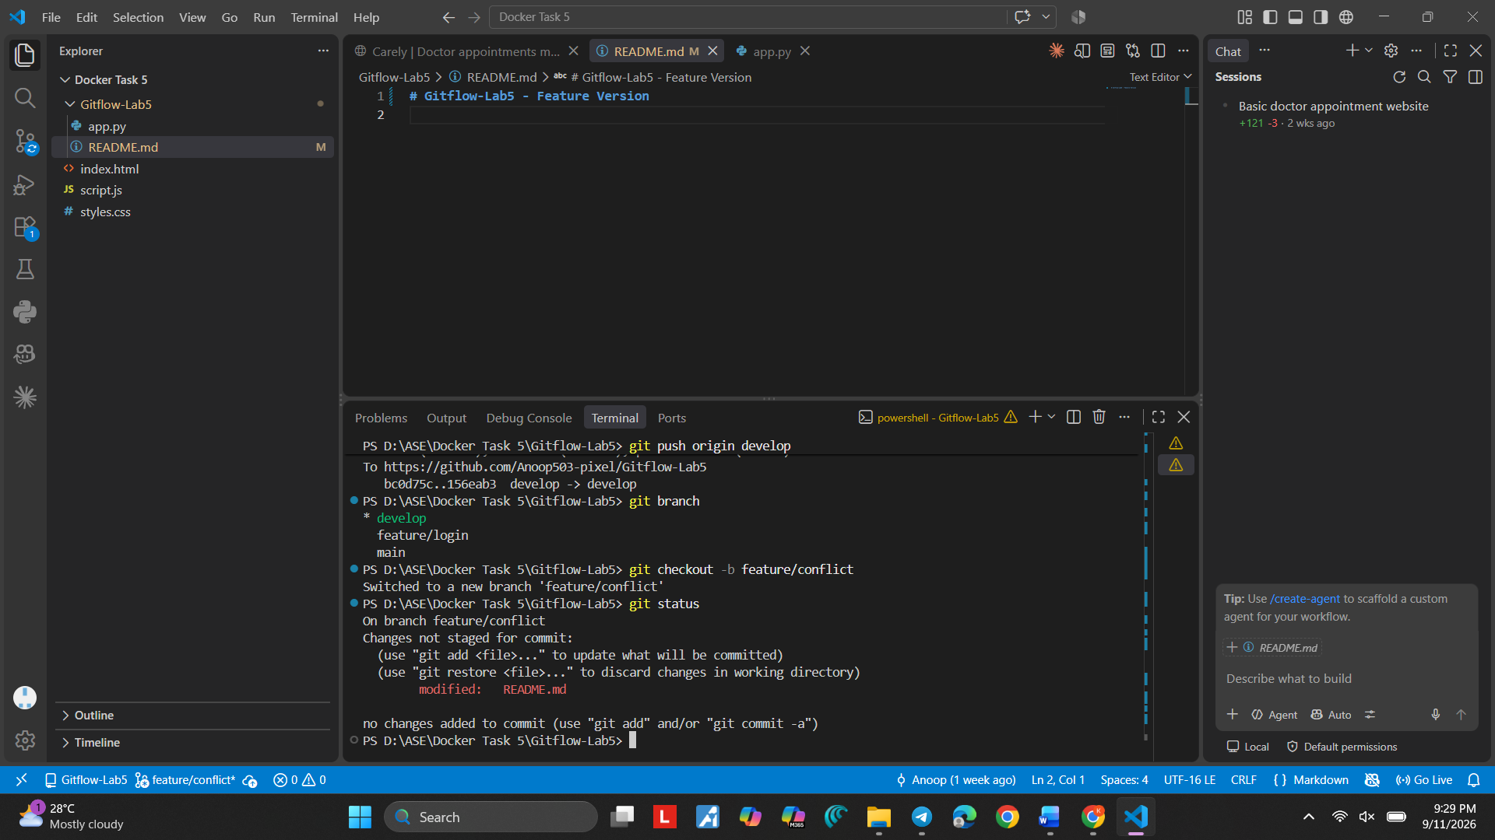

Screenshot 36 — Step 36

Step 37. Stage README.md on feature/conflict
What you see: git add README.md is used and git status shows README.md staged.
Simple explanation: The feature-side README change is ready to commit.

Command:
git add README.md
Purpose: Stages the feature-side README change.
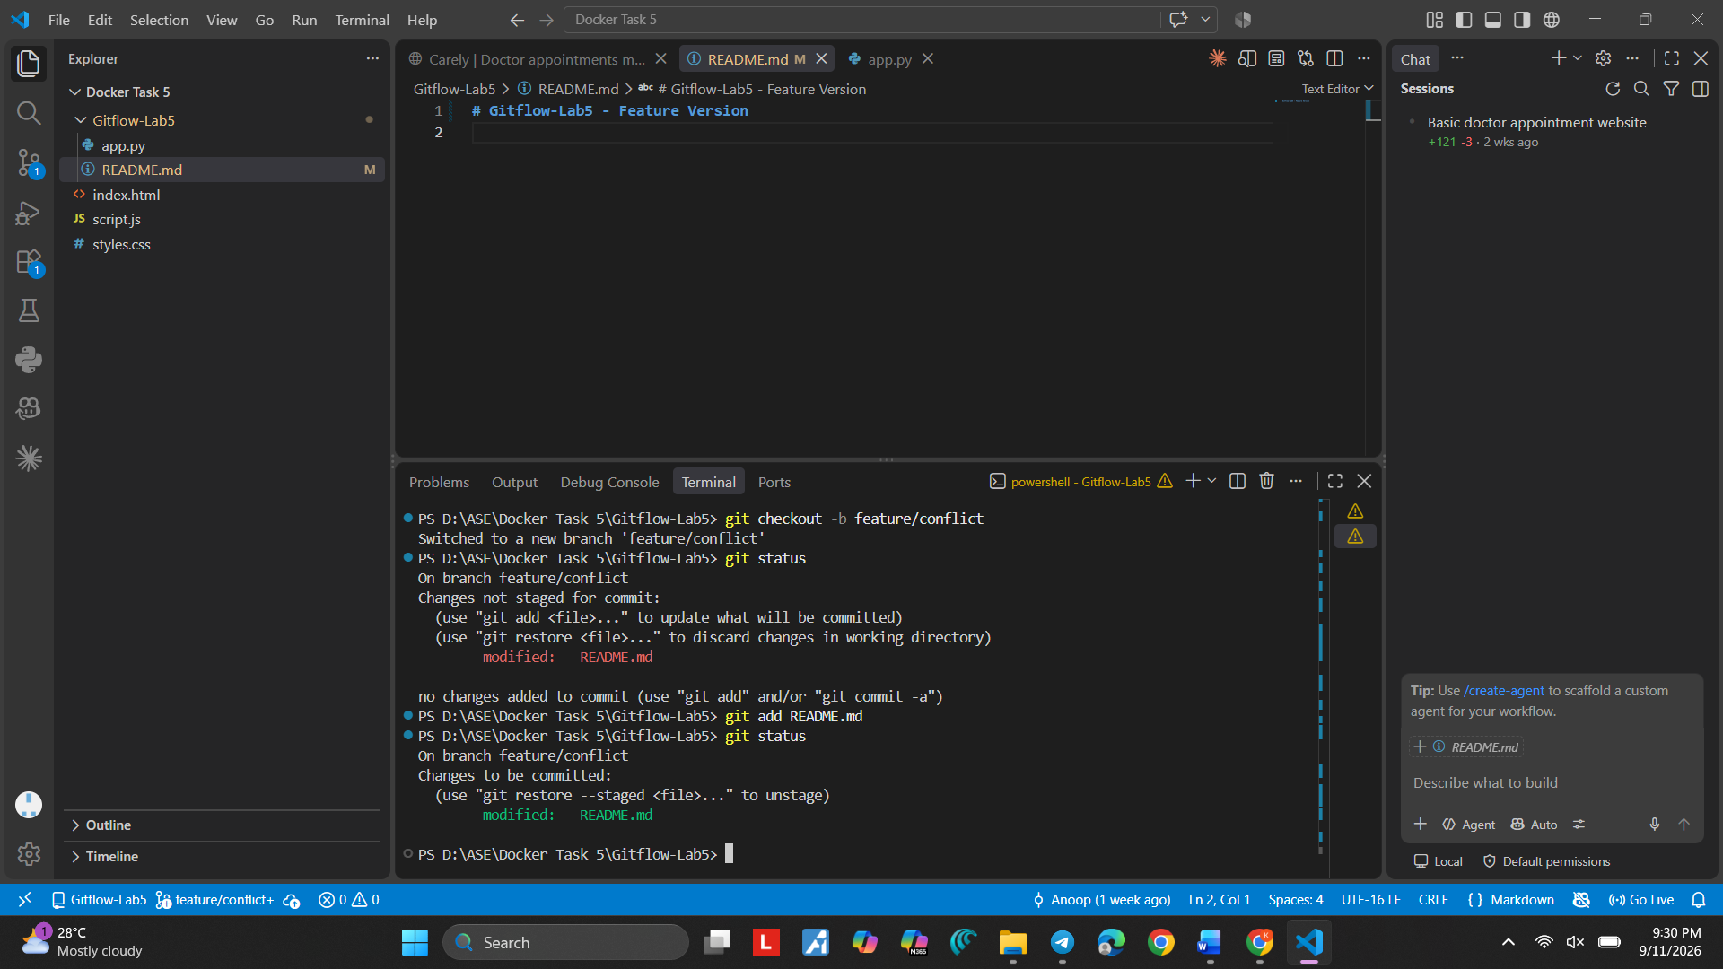
Screenshot 37 — Step 37

Step 38. Commit the Conflict Feature
What you see: The terminal shows the commit command for the conflict feature.
Simple explanation: The feature-side README version is saved in Git history.

Command:
git commit -m "Update README for conflict feature"
Purpose: Saves the feature-side README change.
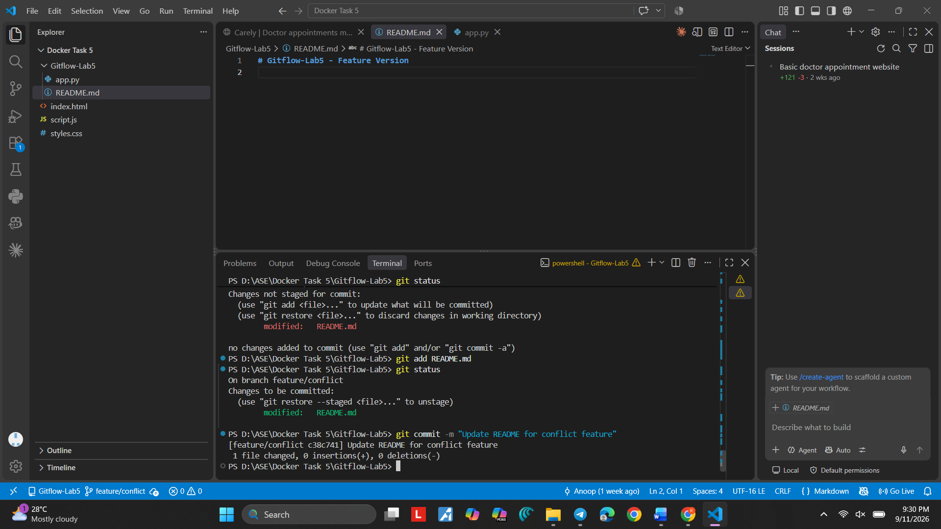
Screenshot 38 — Step 38

Step 39. Confirm the Conflict Feature Commit
What you see: The terminal shows the successful "Update README for conflict feature" commit.
Simple explanation: The feature/conflict branch now has its own README change.

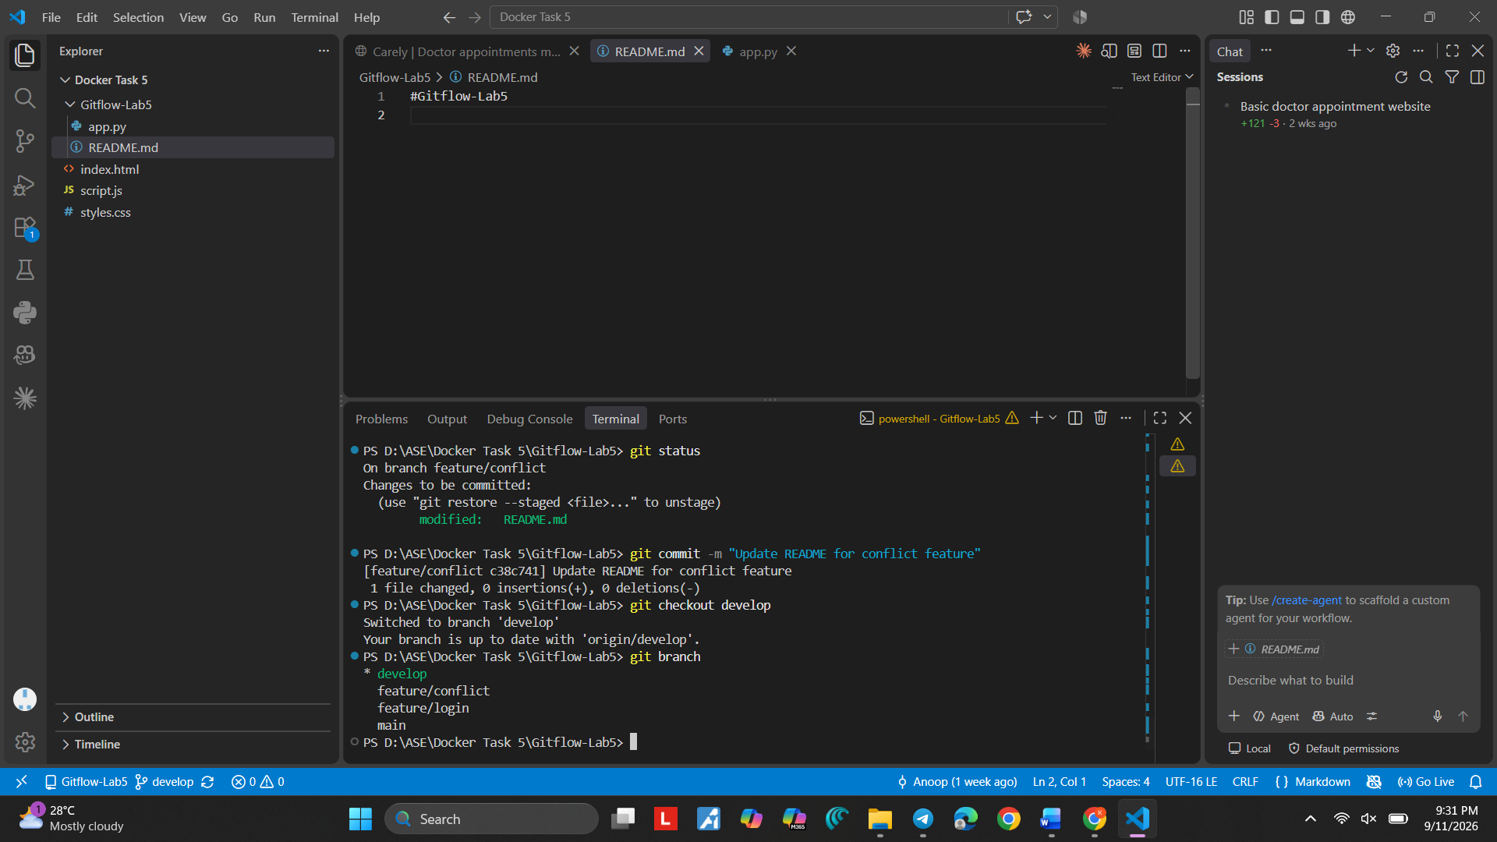
Screenshot 39 — Step 39

Step 40. Create the Develop Version
What you see: README.md shows "Gitflow Lab 5 - Develop Version".
Simple explanation: Now a different README version is prepared on develop.
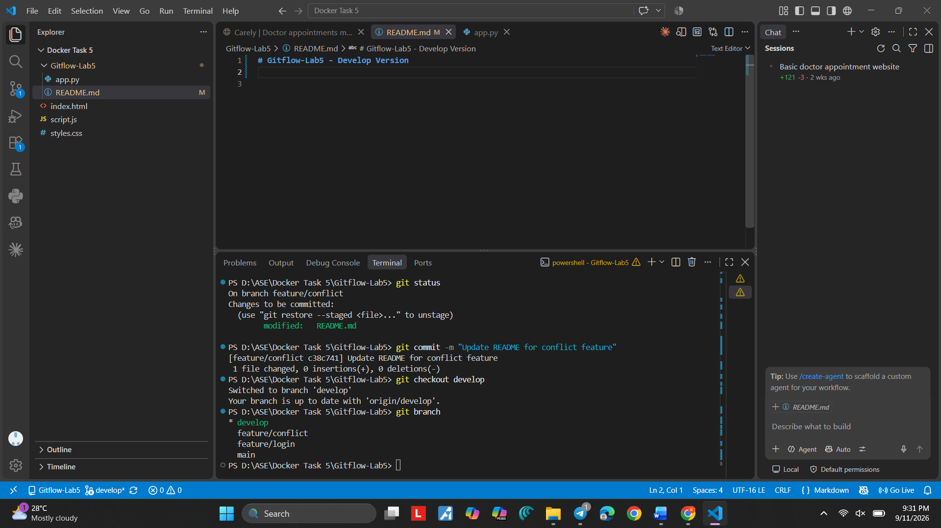
Screenshot 40 — Step 40

Step 41. Review the Branch History
What you see: VS Code Source Control/Timeline shows develop, feature/conflict, feature/login, and main in the history.
Simple explanation: The history helps us see that different branches contain different changes.

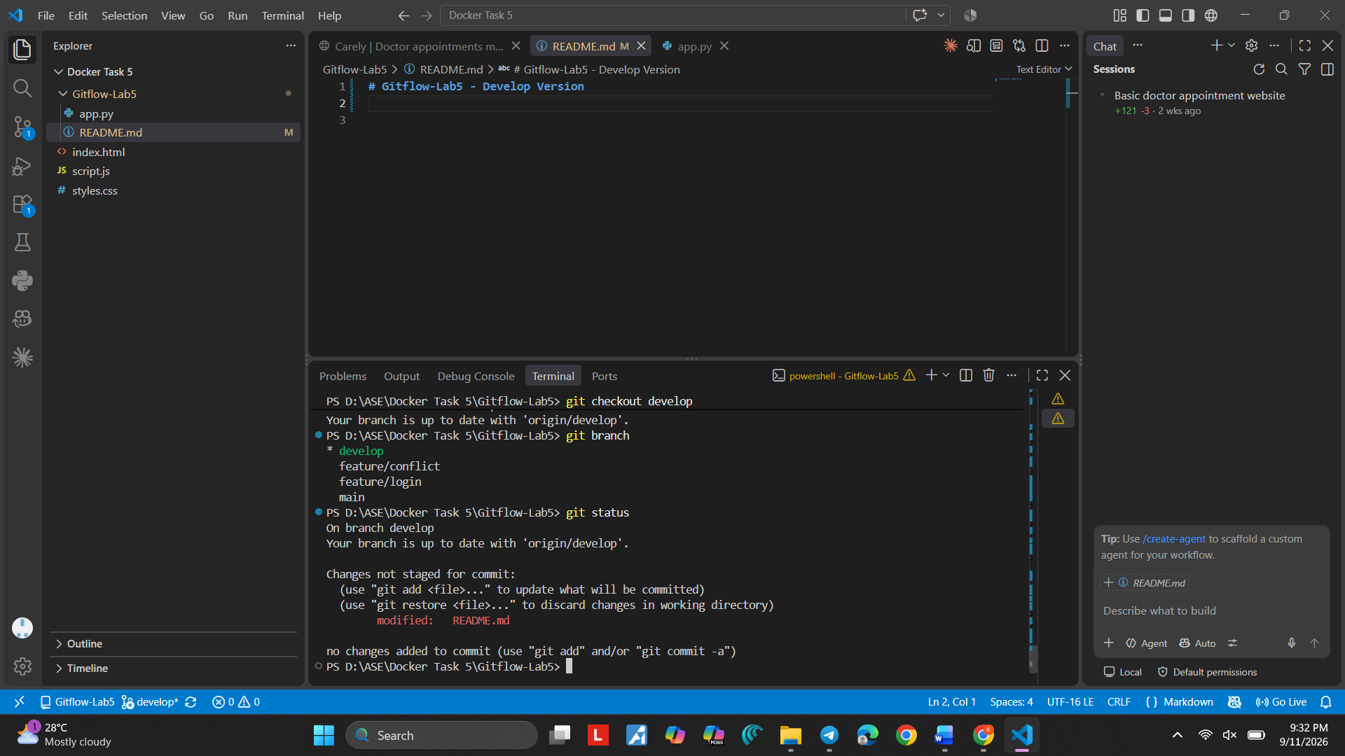
Screenshot 41 — Step 41

Step 42. Review the Project History
What you see: VS Code shows the Gitflow-Lab-5 project and the recorded README changes.
Simple explanation: The Timeline is useful for seeing saved file changes over time.
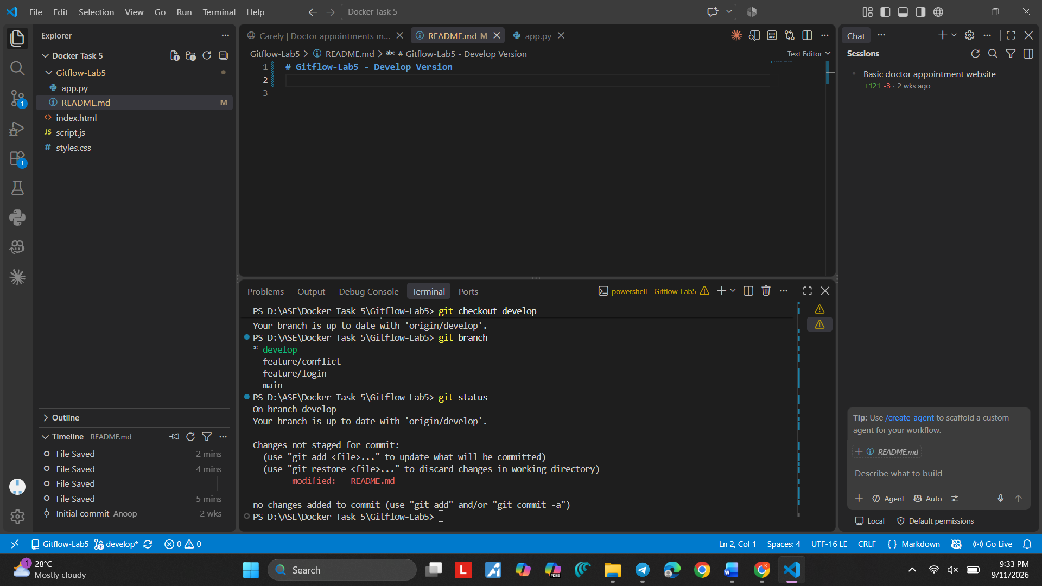
Screenshot 42 — Step 42

Step 43. Continue the Develop Change
What you see: README.md again shows the develop version in VS Code.
Simple explanation: This is the develop-side README content that will be different from the feature version.

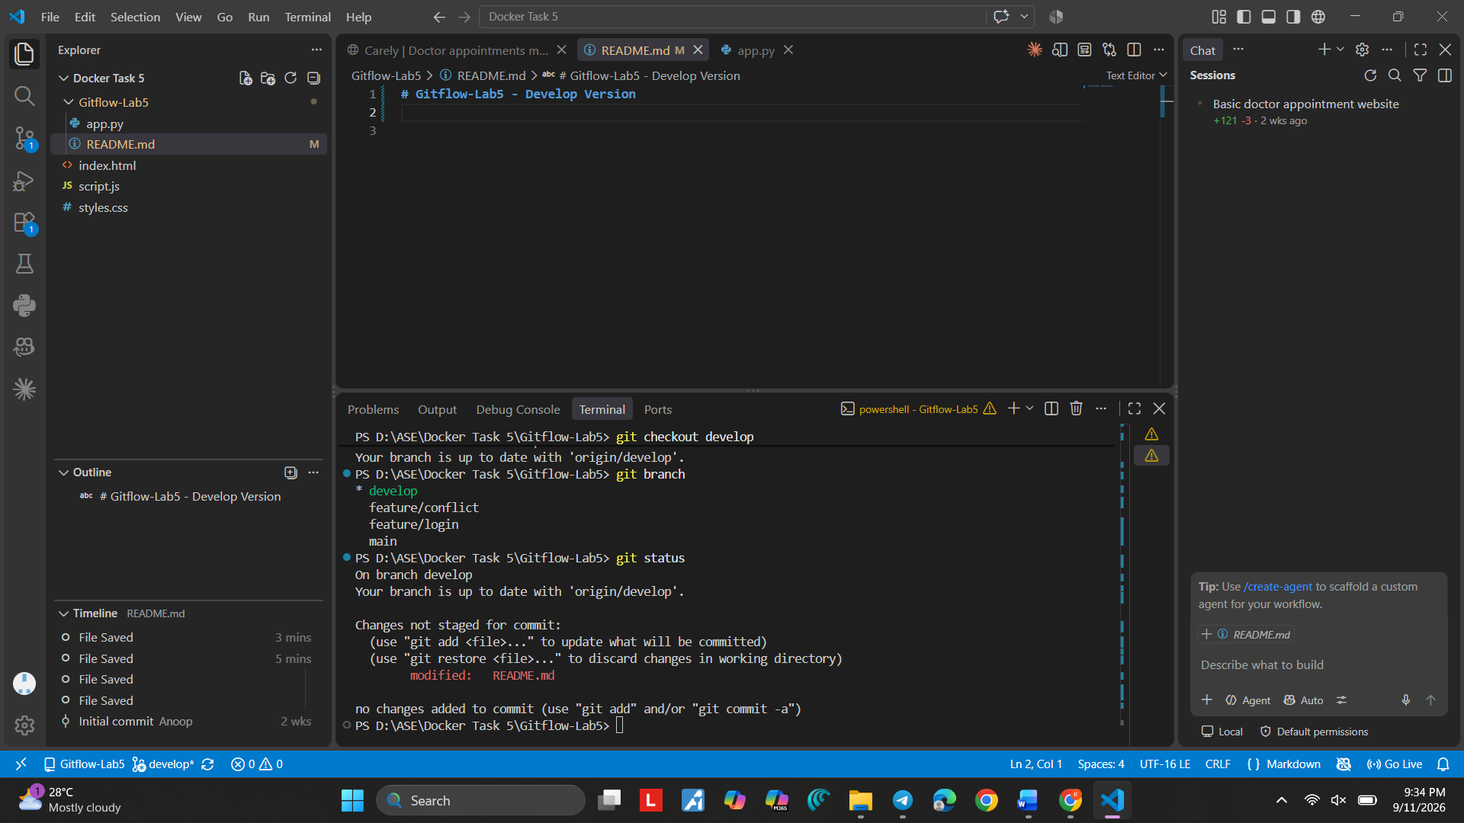
Screenshot 43 — Step 43

Step 44. Check develop Status
What you see: git status shows README.md modified on develop.
Simple explanation: Git has detected the change and it is ready to be staged.

Command:
git status
Purpose: Shows that README.md is modified.
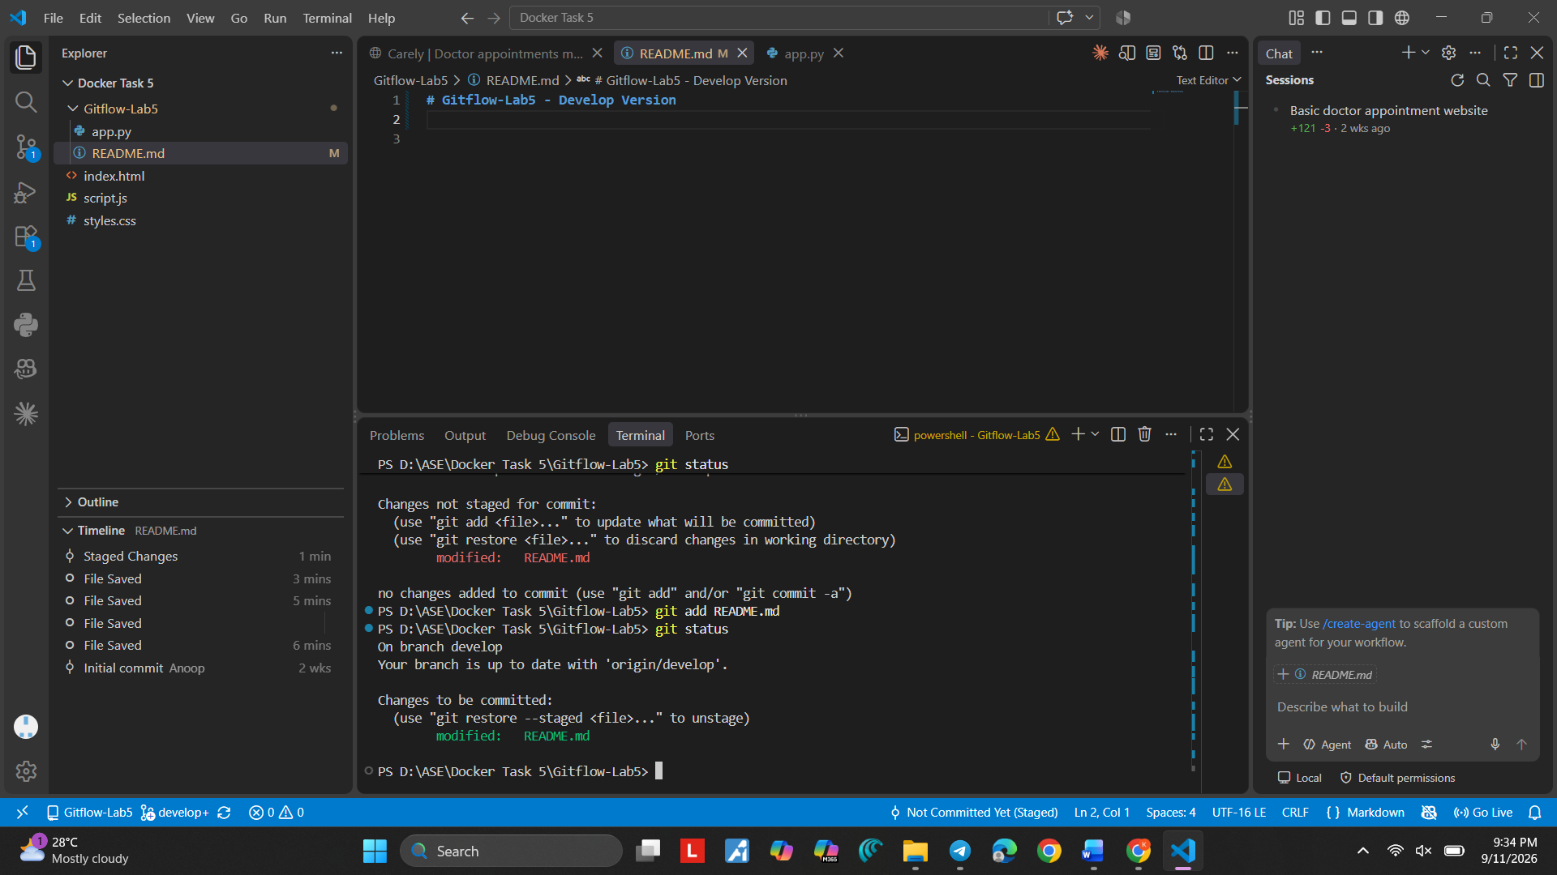
Screenshot 44 — Step 44

Step 45. Stage the Develop Change
What you see: VS Code Source Control shows the README.md change staged.
Simple explanation: The develop-side change is now ready for commit.
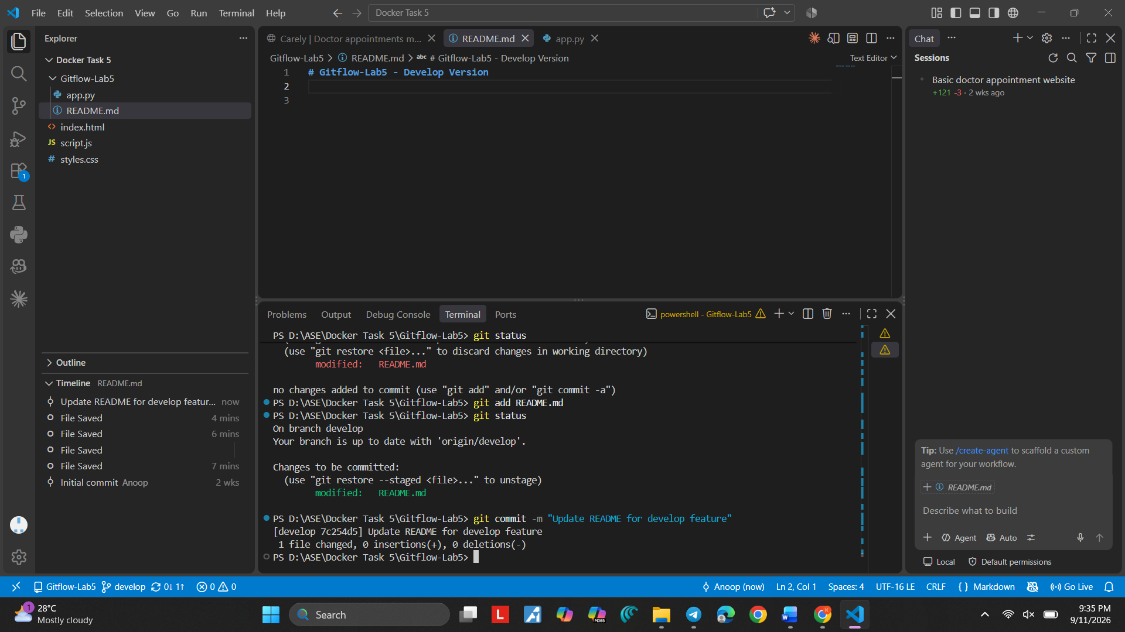
Screenshot 45 — Step 45

Step 46. Commit the Develop README
What you see: The terminal shows git add README.md, git status, and the commit command.
Simple explanation: This saves the develop-side README change in Git history.

Command:
git commit -m "Update README on develop"
Purpose: Saves the develop-side README change.
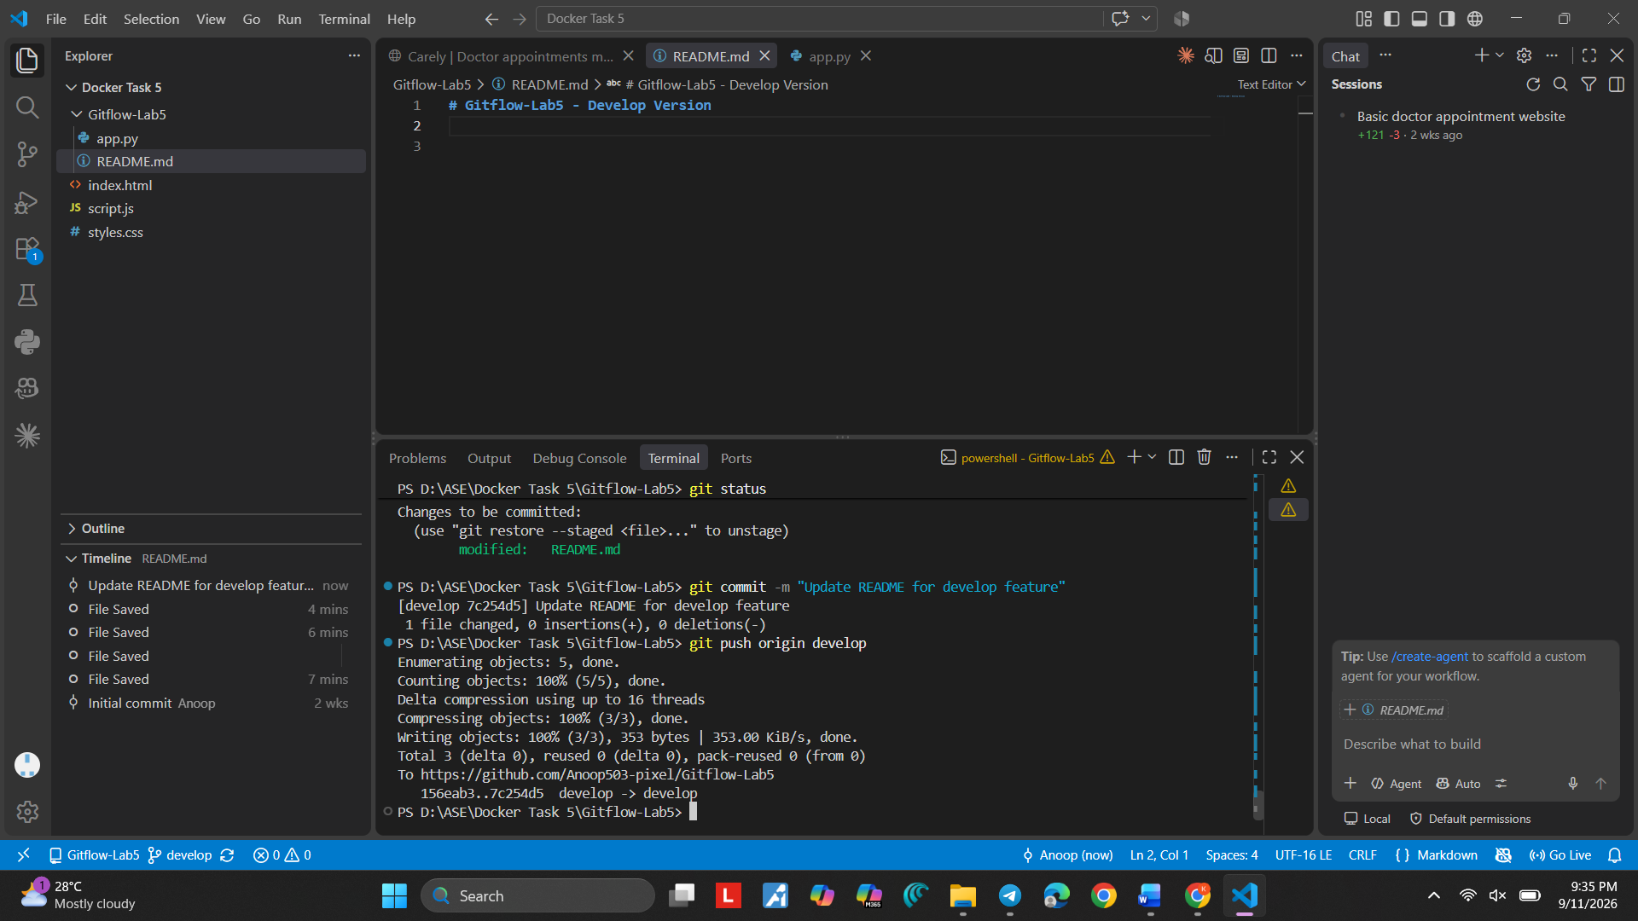

Screenshot 46 — Step 46

Step 47. Create the Conflict Version
What you see: README.md shows "Gitflow Lab 5 - Conflict Version".
Simple explanation: This is another visible version of the same README file.
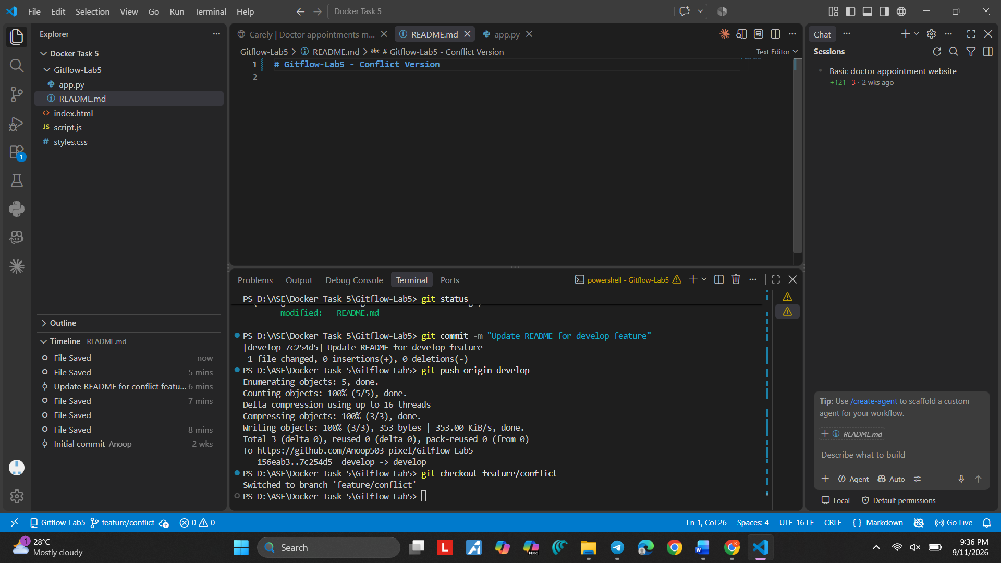
Screenshot 47 — Step 47

Step 48. Open the Merge State
What you see: VS Code shows README.md in the conflict workflow and Source Control information.
Simple explanation: The project is now ready for the merge that will produce the conflict.
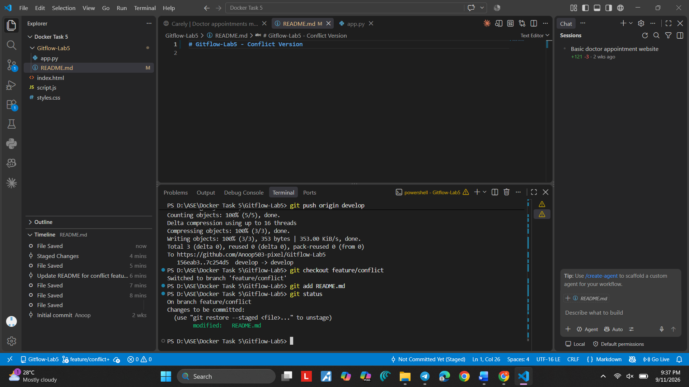
Screenshot 48 — Step 48

Step 49. Review the Conflict-Feature History
What you see: The VS Code Timeline shows the conflict-feature README update and saved files.
Simple explanation: The Timeline records the previous feature changes.
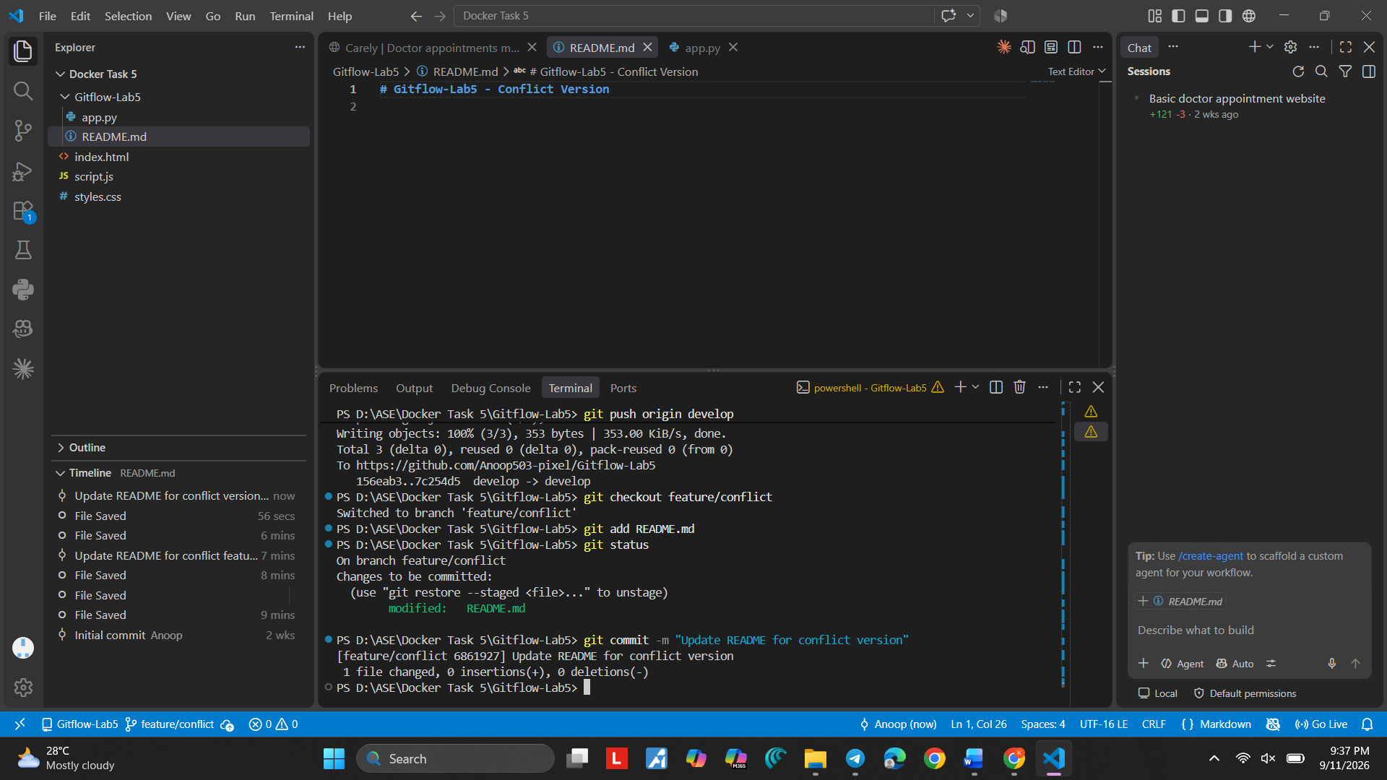
Screenshot 49 — Step 49

Step 50. Review the Develop History
What you see: The VS Code Timeline shows the develop README update and saved files.
Simple explanation: The Timeline records the develop-side changes.
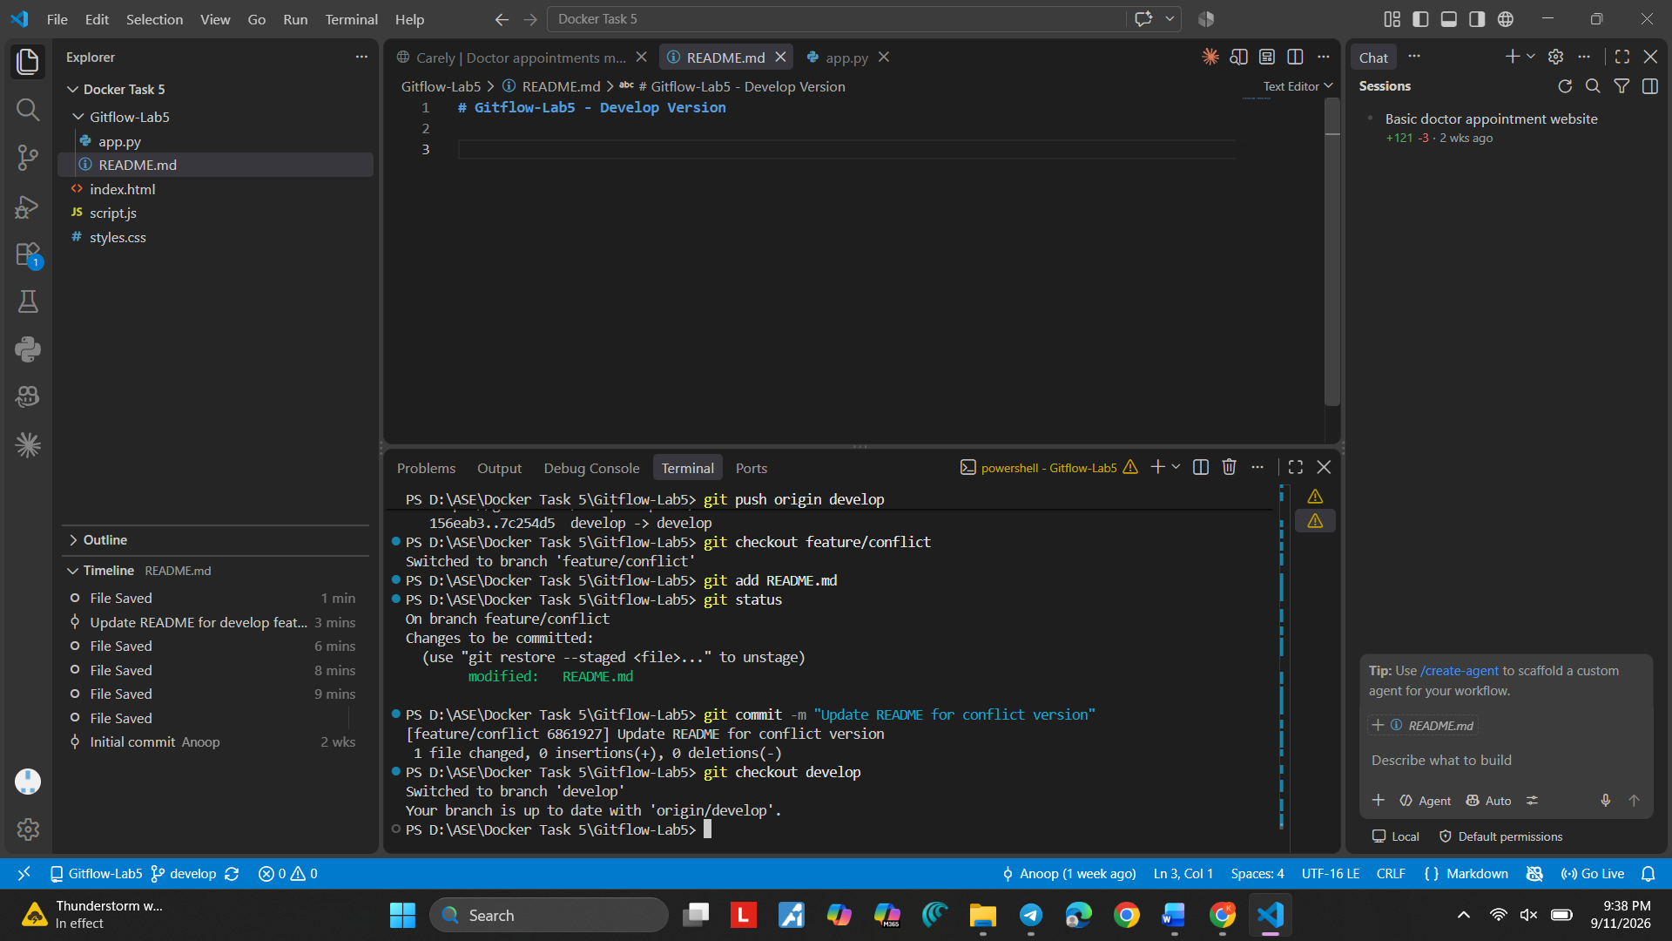

Step 51. Create Another Develop Version
What you see: README.md shows "Gitflow Lab 5 - Another Develop Version".
Simple explanation: The develop branch now has a version that is different from the feature branch version.
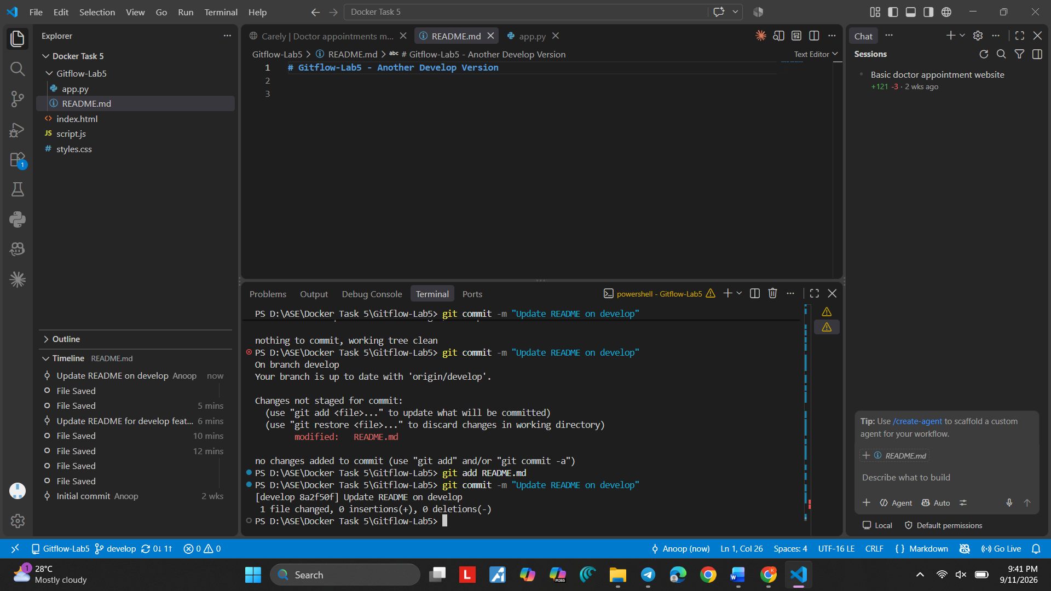
Screenshot 51 — Step 51
Step 52. Open the Merge Editor
What you see: VS Code Merge Editor shows Incoming develop content and Current feature/conflict content for README.md.
Simple explanation: Git cannot automatically decide which version to keep. The Merge Editor shows both sides.
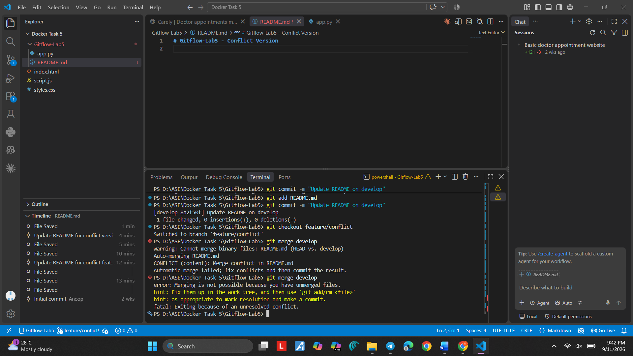

Screenshot 52 — Step 52

Step 53. See Both Versions Together
What you see: The Merge Editor shows the two README versions and the result area.
Simple explanation: Choose the correct content and make one final clean version in the result area.
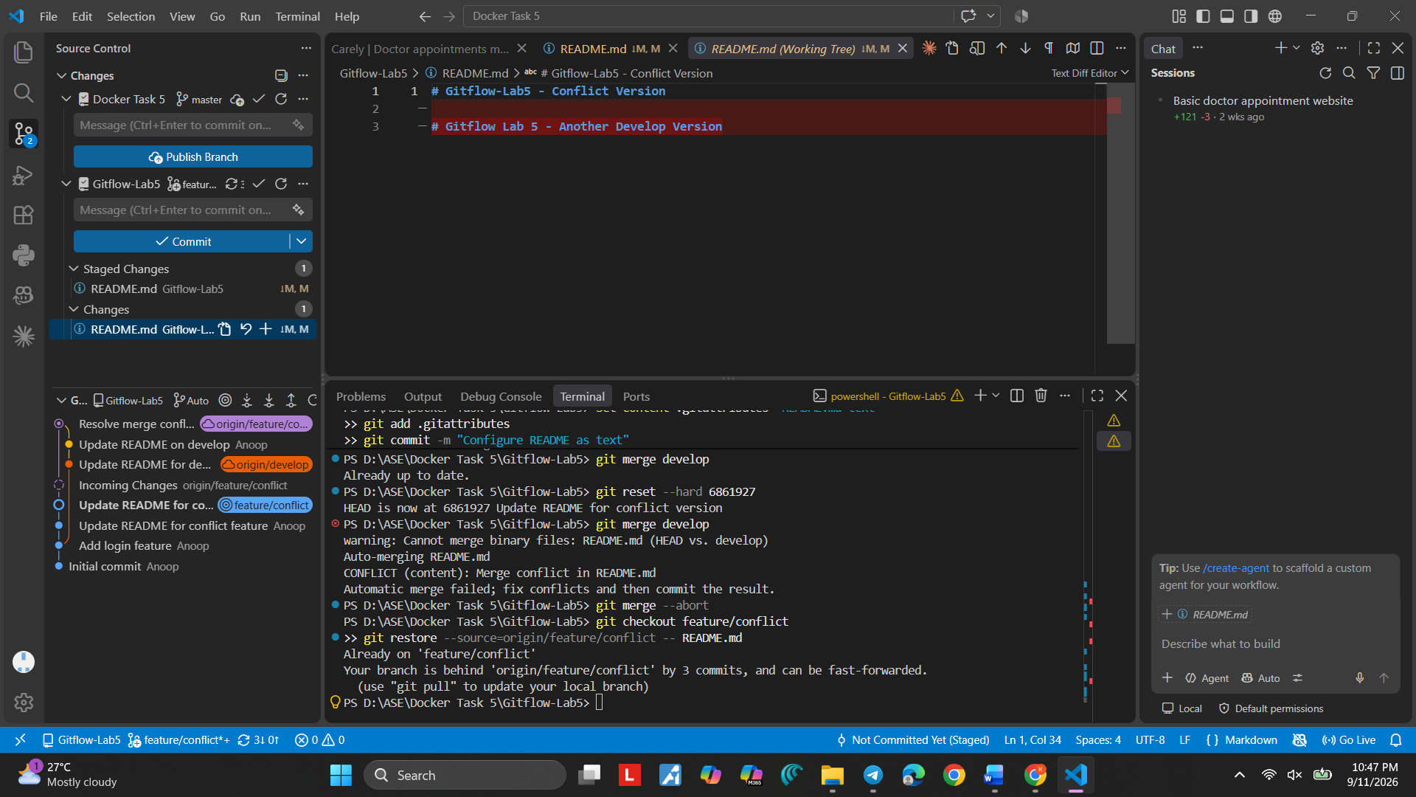
Screenshot 53 — Step 53

Step 54. Complete the Conflict Resolution in Source Control
What you see: VS Code Source Control shows the merge state and the staged README.md.
Simple explanation: After the file is corrected, it must be staged and the merge must be completed with a commit.

Command:
git add README.md
Purpose: Stages the resolved README file.

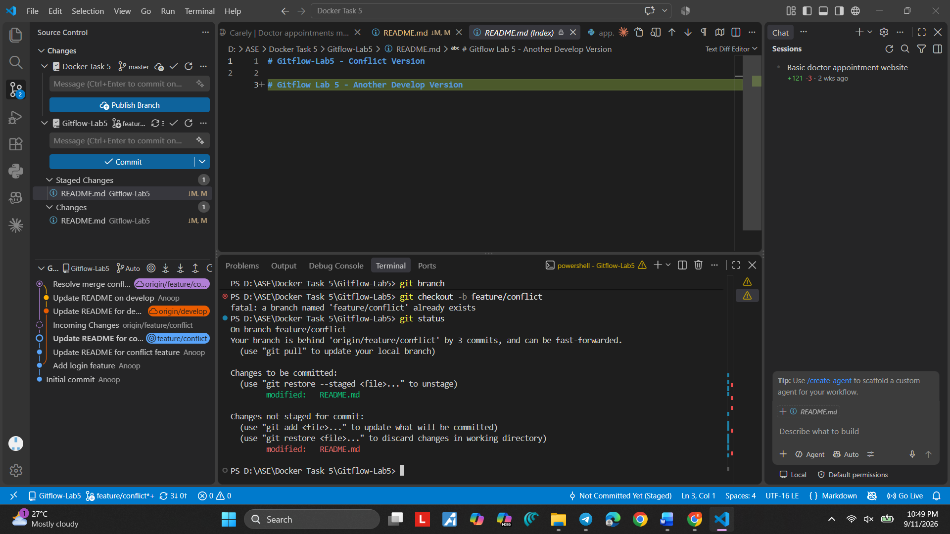
Screenshot 54 — Step 54

Step 55. Review the Merge History
What you see: The terminal and Source Control show the merge history and Fast-forward/app.py information.
Simple explanation: This is a history check after the merge work.
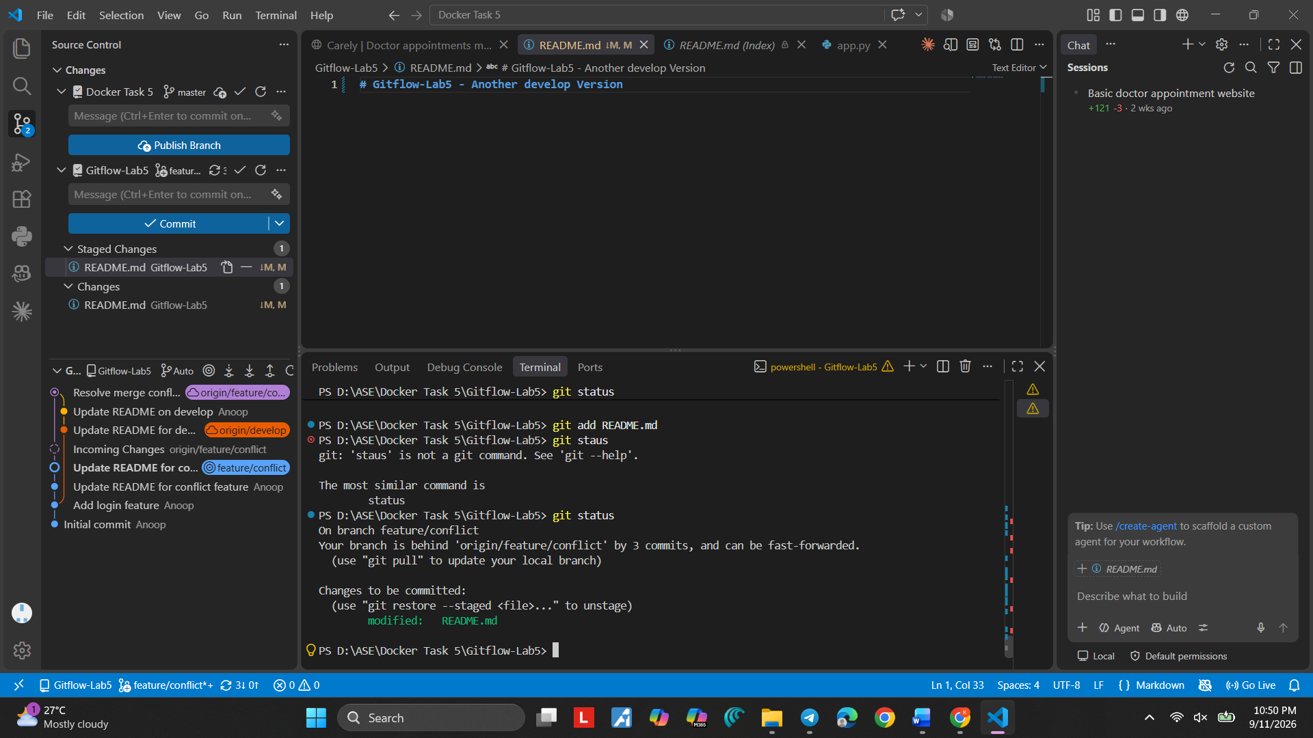
Screenshot 55 — Step 55

Step 56. Review the Final Local History
What you see: VS Code shows the project history after the conflict workflow.
Simple explanation: The history should now contain the work from the branches and the merge.

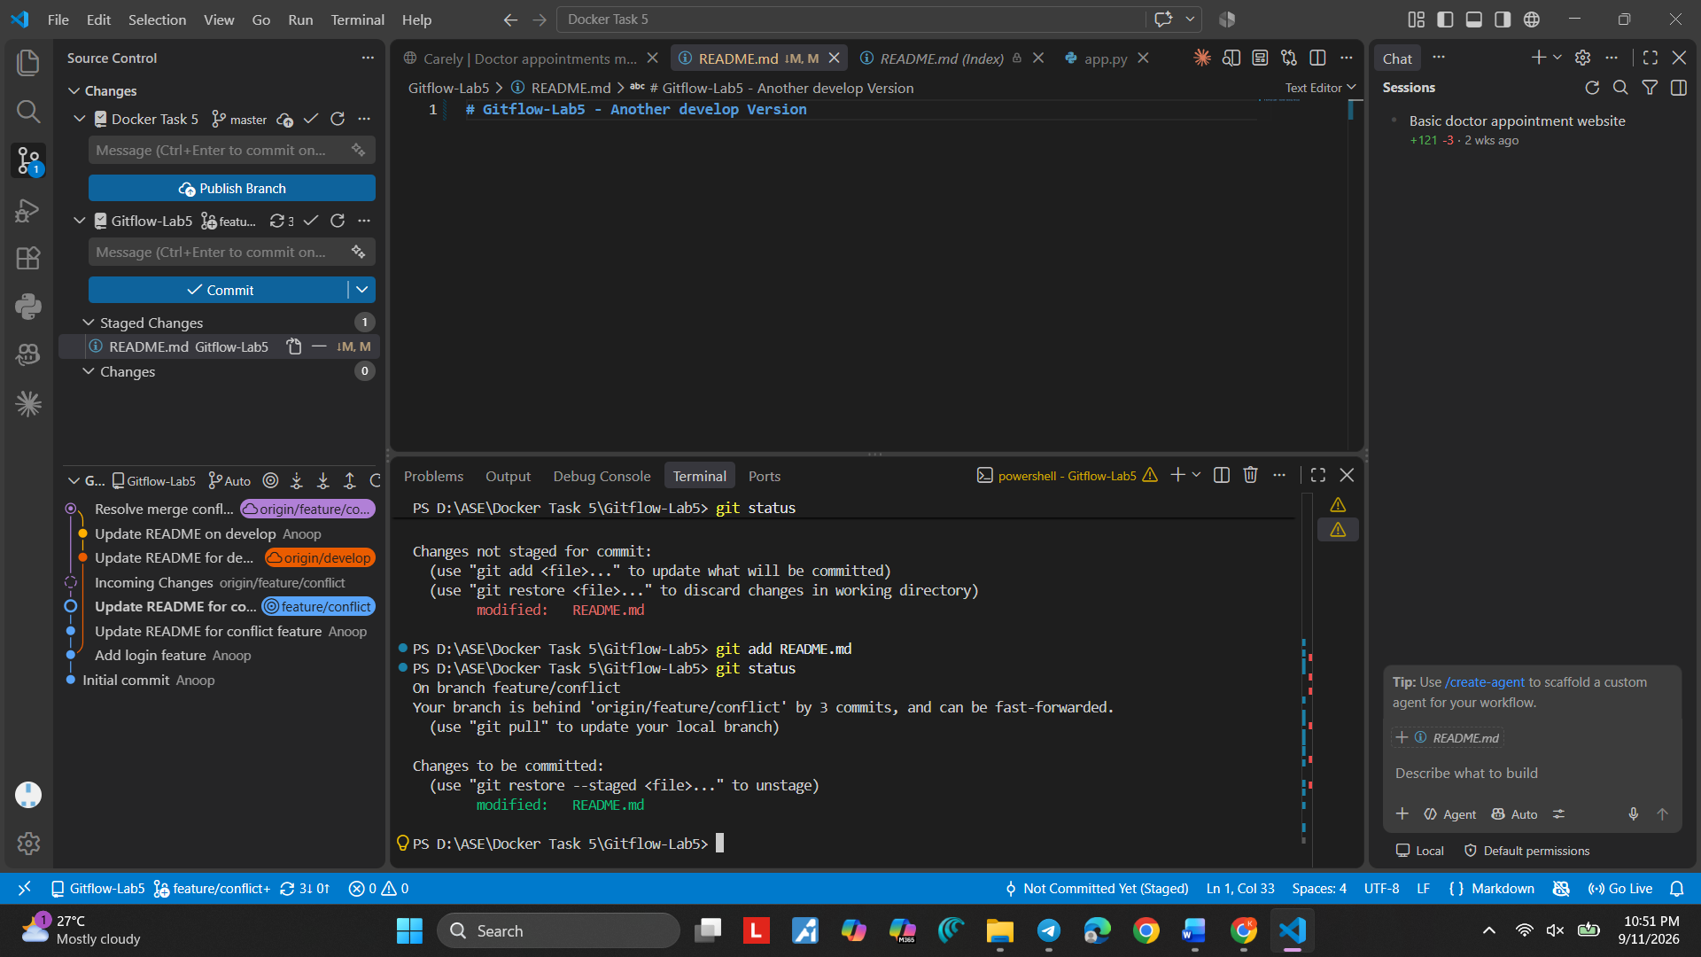
Screenshot 56 — Step 56

Step 57. Check GitHub Branches and Recent Pushes
What you see: GitHub shows recent pushes for feature/conflict and develop.
Simple explanation: This confirms that the branches have been pushed to GitHub.
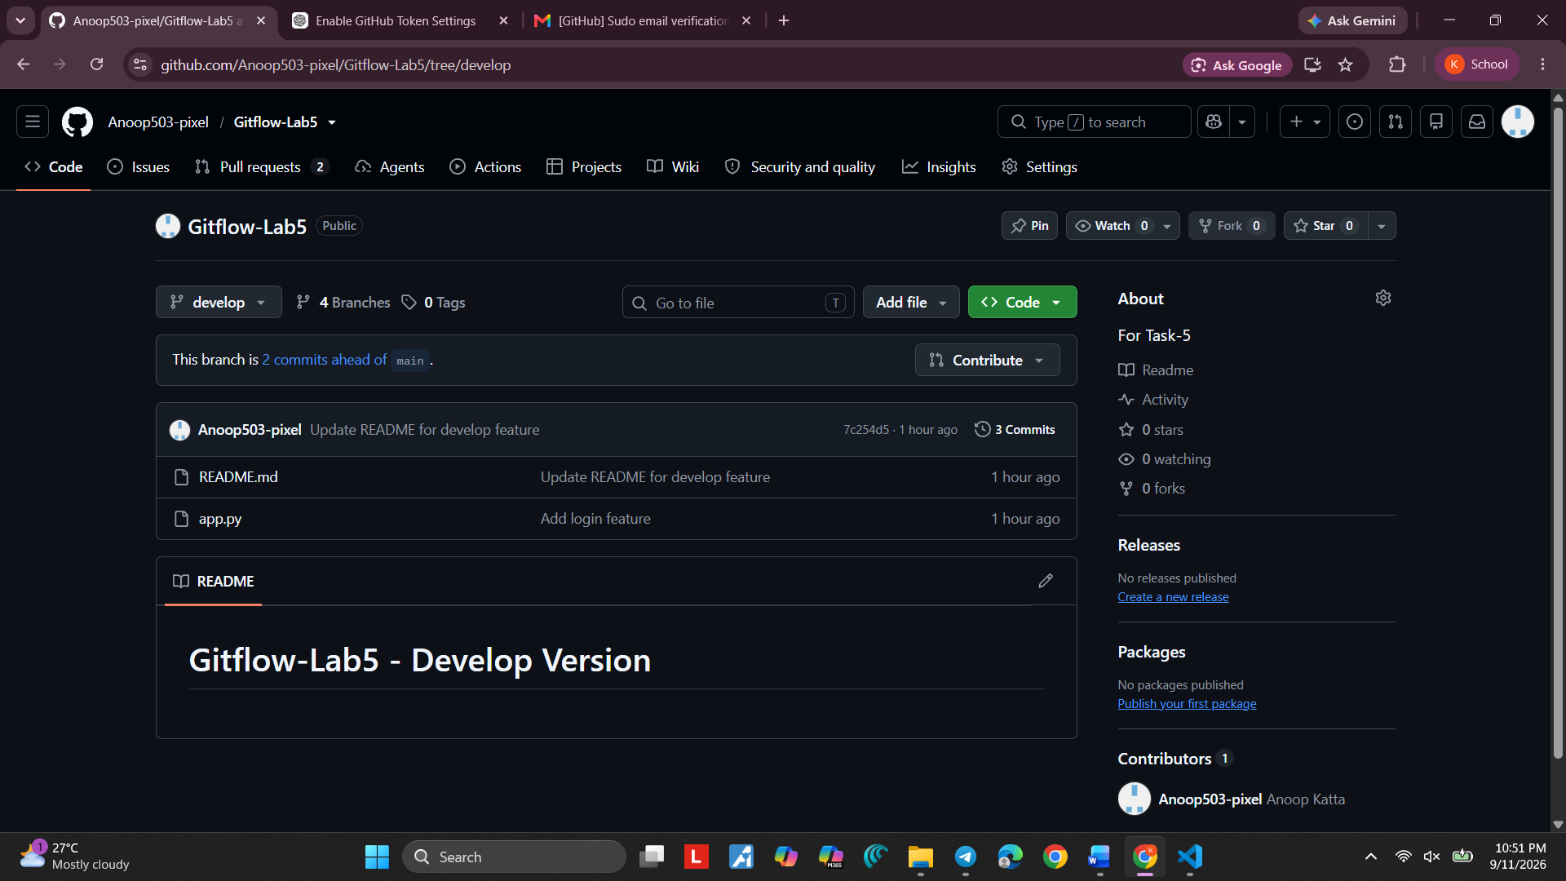xx
Screenshot 57 — Step 57

Step 58. Open the Final develop Branch
What you see: GitHub shows the develop branch with README.md, app.py, the commit history, and the README content.
Simple explanation: This is the final verification screen. The develop branch contains the integrated project work.
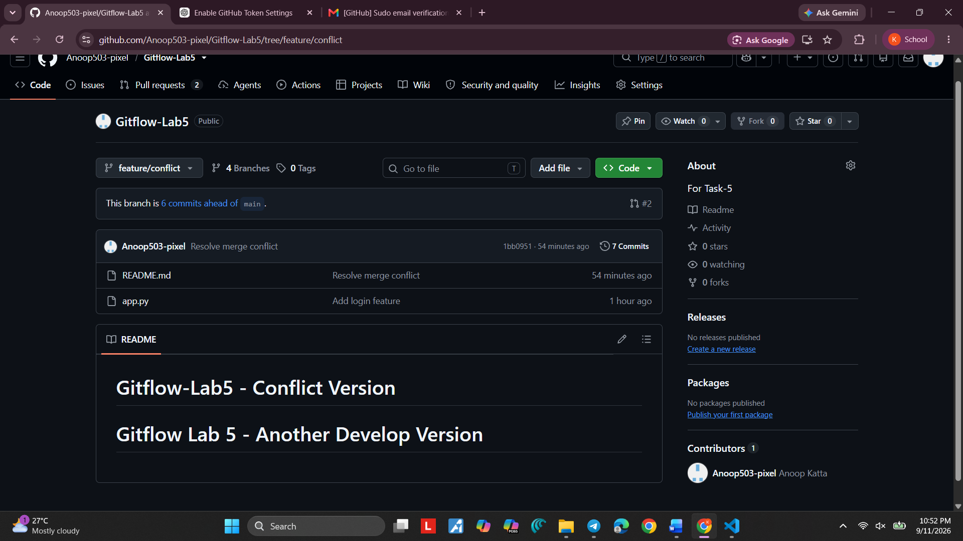
Screenshot 58 — Step 58

Final Revision
Remember the main flow: Create GitHub repository → connect the local project → create develop → create feature/login → commit → push → merge into develop → create feature/conflict → make different changes
→ merge → resolve the conflict → stage → commit → push → verify on GitHub.

Most Important Commands
- git status —
- git branch —
- git checkout -b branch-name —
- git add file-name —
- git commit -m "message" —
- git push —
- git merge branch-name —
- python app.py —

